EFFECT OF STORAGE ON LEVELS OF VOLATILE COMPOUNDS IN n-HEXANE EXTRACTS FROM SELECTED MEDICINAL PLANT BLENDS

BY

DICKSON SAMUEL CHIBUEZEM
MATRIC NO: 20/2134

IN PARTIAL FUFILMENT OF THE COURSE REQUIREMENTS FOR THE COURSE RESEARCH PROJECT (BCHM 490) FOR THE AWARD OF THE BACHELOR OF SCIENCE DEGREE (BSc. HONS) IN BIOCHEMISTRY

SUBMITTED TO
DEPARTMENT OF BIOCHEMISTRY
SCHOOL OF BASIC MEDICAL SCIENCES
BENJAMIN CARSON (SNR.) COLLEGE OF HEALTH AND MEDICAL SCIENCES
BABCOCK UNIVERSITY, ILISAN-REMO, OGUN STATE

MAY, 2024

CERTIFICATION
This is to certify that the project titled “Effect of storage levels of volatile compounds in n-hexane extracts from selected medicinal plant blends was researched, reported, and defended by Dickson Samuel Chibuezem 20/2134, under the supervision of Dr. O.S. Shokunbi, in partial fulfillment of the requirement for the award of Bachelor of Science (B.Sc) Degree in Biochemistry, Babcock University, Ilishan-Remo, Ogun State.

Dickson Samuel Chibuezem ______________________
(Student) Signature & Date

Dr. Olutayo S. Shokunbi _____________________
(Supervisor) Signature & Date

Dr. A. A Kayode ______________________
(Head of department) Signature & Date

DEDICATION
This research is dedicated to God, who bestowed His matchless and amazing Grace throughout my academic pursuit in Babcock University, and to parents, Mr. and Mrs. Dickson, for their love and continuous support.

ACKNOWLEDGEMENTS
First and foremost, I am grateful to God for helping me throughout my research, for giving me strength and determination. I also appreciate my supervisor, Dr. Shokunbi O. S. for this mentorship opportunity. Also, for taking time to teach and guide me. I appreciate the department of Biochemistry for exposing me to research work, writing and presenting scientific findings. I also acknowledge the Chemistry department for granting me access to their laboratories and apparatus. I am grateful to Dr. Anokwuru C. for his guidance and assistance in throughout my project work.
I’m grateful to My parents, Dr. & Mrs. Dickson T.U., and siblings, Jessica and Bestman for their support, prayers and encouragement. I appreciate my friends and colleagues; Molokwu Henry and Aleshinloye Daniella for their support. I acknowledge my project partners, Ajiboye Toluwase and Innocent Anietie for assistance provided.

TABLE OF CONTENTS
Content Page
Title Page i
Certification ii
Dedication iii
Acknowledgement iv
Table of Contents v
List of Tables viii
List of figures ix
Abstract x
CHAPTER ONE: INTRODUCTION
  - Background to the study 1
  - Statement of the problem 2
  - Objectives of the study 3
  - Significance of the study 3
CHAPTER TWO: LITERATURE REVIEW
2.1 Medicinal plants 4
2.2 Phytochemicals 4
2.2.1 Alkaloids 5
2.2.2 Terpenes 6
2.2.3 Phenolics 7
2.2.4 Glycosides 10
2.3 Factors Affecting Phytochemical Profiles 10
2.3.1 Plant factors 10
2.3.2 Storage conditions 10
2.3.3 Extraction methods 10
2.4 Essential Oils 11
2.4.1 Volatile compounds 13
2.4.2 Industrial uses of volatile compounds 13
2.4.3 Therapeutic benefits of volatile compounds 15
2.5 Polyherbal Formulations 16
2.5.1 Medicinal applications of plant blends 18
2.5.2 Phytonutrient complexes 19
2.5.3 Phytochemical interactions in a polyherbal 19
formulation
2.5.4 Toxicity concerns of polyherbal formulations 21
2.6 Polyherbal formulations from Syzgium aromaticum, 22
Ocimum gratissimum, Zingiber officinale Roscoe,
and Cymbopogon citratus
2.6.1 Syzgium aromaticum 22
2.6.2 Ocimum gratissimum 25
2.6.3 Zingiber officinale Roscoe 27
2.6.4 Cymbopogon citratus 30
2.7 Soxhlet Extraction 31
2.8 GC-MS Technique 32
CHAPTER THREE: MATERIALS & METHODS
3.1 Study location 33
3.2 Food sample selection and collection 33
3.3 Sample preparation 33
3.4 Equipment apparatus 34
3.5 Solvent 34
3.6 Preparation of Samples for Soxhlation Process 34
3.6.1 Soxhlation process 35
3.7 Sample Preparation for GC-MS analysis 36
3.8 GC-MS analysis 37
CHAPTER FOUR: RESULTS
4.1 Levels of AACs in Lemongrass 38
4.2 Levels of ACCs in blend A 42
4.3 Levels of ACCs in blend B 45
4.4 Levels of ACCs in blend C 49
CHAPTER FIVE: DISCUSSION, CONCLUSION, AND RECOMMENDATION
5.1 Discussion 55
5.2 Conclusion 59
5.3 Recommendation 59
REFERENCES 60

LIST OF TABLES
Table Page
Table 2.1: Common polyherbal formulations in Nigeria 18
Table 3.1: Specified plants for sample blends 33
Table 4.1: Levels of aroma-active compounds (AAC) 39
in n-hexane extract from lemongrass before and after storage
Table 4.2: Levels of aroma-active compounds (AAC) 43
in n-hexane extract of blend A before and after storage
Table 4.3: Levels of aroma-active compounds (AAC) 47
in n-hexane extract of blend B before and after storage
Table 4.4 : Levels of aroma-active compounds (AAC) 51
in n-hexane extract of blend C before and after storage

LIST OF FIGURES
Figure Page
Figure 2.1: Classification of Terpenes (Mabou et.al, 2021) 6
Figure 2.2: Schematic Representation of Terpene 7
Biosynthesis (Abdallah & Quax, 2017)
Figure 2.3: The Schikimate pathway (Tzin et al., 2013) 9
Figure 2.4: The phenylpropanoid pathway 9
(Gutierrez-Gonzalez et al., 2010)
Figure 2.5: Methods of essential oil extraction and 12
isolation (Herman et.al, 2019)
Figure 2.6.1: Clove buds (Kamatou et al., 2012) 23
Figure 2.6.2: (Ocimum Gratissimum, 2024 25
Figure 2.6.3: Ginger roots (Parmar, 2023) 28
Figure 2.6.4: Lemongrass (Lemongrass, 2022) 30
Figure 4.1: 5 Hydroxy-1-(4-hydroxy-3- 38
methoxyphenyl)decan-3-one
Figure 4.2: phenol, 2-methoxy-4- 38
(2-propenyl)-, acetate (NIST, 2023)
Figure 4.3: Citral (Alam et al., 2018) 38
Figure 4.4: Citral (Alam et al., 2018) 42
Figure 4.5: Thymol (Dong et al., 2020) 42
Figure 4.6: Eugenol (Ulanowska, 2021) 42
Figure 4.7: Bicyclo[3.1.1]hept-2-ene 42
,2,6-dimethyl-6-(4-methyl-3-pentenyl)- (NIST, 2023)
Figure 4.8: Eugenol (Ulanowska, 2021) 46
Figure 4.9: Phenol, 2-methoxy-3- 46
(2-propenyl) (NIST, 2023)

ABSTRACT
Medicinal plants are widely used for bioactive potency and are often combined in polyherbal formulations for maximum benefits. Essential oils and volatile extracts possess industrial and therapeutic value, credit to their rich stores of volatile compounds. This study investigated effect of storage on levels of volatile compounds in blends of medicinal plants, consisting of ginger, scent leaf, lemongrass, and clove. The analysis was performed using gas chromatography-mass spectrometry (GC-MS) to identify the volatile profiles of n-hexane extracts of each blend. In the initial analysis, lemongrass extract showed a high percentage of citral (13.10%), while blend A had thymol (37.05%) and citral (19.03%) as its predominant constituents. Blend B had eugenol (53.25%) as its most abundant volatile. Blend C revealed Isoaromadendrene epoxide (11.97 %), and caryophyllene (13.74 %) as its most abundant volatiles. After four weeks of storage, in air tight containers, the volatile profile of lemongrass varied, with citral being absent and other compounds, such as eugenol, and caryophyllene, becoming predominant. Blend A maintained a higher level of consistency, with the reoccurrence of p-cymene, and thymol, although eugenol replaced citral as its most abundant compound. Blend B displayed the highest level of consistency, with six volatile compounds remaining mutually present in the current and previous analyses, while blend C revealed high levels of oxidation and isomerism. These changes may affect the physical and biological activities of the formulations rendering them substandard. Further research is necessary to optimize the formulation ratios, processing methods, and storage conditions of these blends to ensure optimal efficacy.

Keywords: Volatile compounds, polyherbal formulation, aroma therapy, bioactives, stability.

Word count: 252

CHAPTER ONE

INTRODUCTION

1.1 Background to study
Plants are found persisting in almost every environment across the globe, serving a variety of purposes such as food sources, industrial raw materials and therapeutic agents (Wali et al., 2022). For centuries, plants have played a pivotal role in human health and well-being, serving as a fundamental source of nutrition and medicine across diverse cultures and civilizations. Ancient civilizations such as Egypt, China, India, and Greece have documented and utilized the medicinal properties of numerous plant species for healing purposes, demonstrating the historical significance of plants in preventive and therapeutic practices (Abubakar et al., 2022).
The shift from traditional to modern medicine brought about synthetic drugs that transformed disease treatment but also raised concerns about long-term side effects and toxicity (Karimi et al., 2015). This led to a renewed interest in plant-based therapies that offer holistic benefits by affecting multiple cellular processes,to promote interconnectedness of mind, body, and spirit in health and healing as safer and more sustainable alternatives (Altemimi et al., 2017; Bansal & Priyadarsini, 2022). The utilization of plant-derived extracts for therapeutic purposes is deeply rooted in traditional medicine practices and continues to garner interest in modern pharmacology. These extracts contain a variety of bioactive compounds, such as polyphenols, alkaloids, terpenoids that can be extracted and isolated as active components used in pharmaceuticals and nutraceuticals.
Some plants such as Zingiber officinale ( Ginger), Syzygium aromaticum (Clove), Ocimum gratissimum (Scent Leaf), and Cymbopogon citratus (lemongrass), contain essential oils that posses therapeutic and industrial importances, credit to the vast amounts of volatile constituents that have been identified as potential therapy mediators and fragrance ehancers. These oils can be extracted by employing extraction techniques such as soxhlation, steam distillation, and hydrodistillation amongst others, then further isolated using analytical techniques such as gas chromatography-mass spectrometry (GC-MS) (Rai, 2021; Nortjie et al., 2022). However, factors like storage methods, environmental conditions, and processing techniques, can influence the stability and composition of bioactive compounds in plant essential oils, potentially influencing the efficacy of the extracts. Investigations into how these factors affect the shelf-life and quality of plant extracts can inform decisions in the pharmaceutical and nutraceutical industries for standardization, quality control, and formulation of herbal products ensuring their consistency and efficacy (Harbourne et al., 2013; Bitwell et al., 2023; Sharma et al., 2020) .

1.2 Statement of problem
Despite the recognized therapeutic and industrial potential of plant-derived extracts, there are limited amounts of valuable information on effect of storage on their efficacy and authenticity. Therefore, there is a need to investigate the temporal shifts in phytochemical composition to ensure consistency and efficacy in herbal preparations.

1.3 General objectives
The general objective of this study is to examine the constituent volatile compounds in n-hexane extracts of clove, ginger, lemon grass and scent leaf blends, over a defined period.

1.3.1 Specific objectives
The specific objectives of this study were to;
To extract essential oils from specified blends of clove, ginger, lemon grass, and scent leaf.
To create a baseline for the aroma-active compounds contained in specified blends
To compare the levels of aroma-active compounds in n-hexane extracts of specified blends after one month of storage.

1.4 Significance of the study
Limited information of the volatile compounds present in blends of selected plants, prompts the need to investigate their volatile constituents and create a baseline reference that can advise industrial and therapeutic innovations. Furthermore, by investigating the stability of the active volatile compounds over a period of time, this study will provide valuable insights into the shelf-life and quality of plant extracts, informing decision-making in the development of herbal products with consistent bioactive profiles.

CHAPTER TWO
REVIEW OF LITERATURE

2.1. Medicinal Plants
The term "medicinal plants" refers to plants validated for their medicinal properties, offering therapeutic benefits in disease mitigation, prevention, or management. These plants contain phytochemicals and bioactive compounds with therapeutic properties utilized for treating various health conditions. Traditional medicinal plants have a long history in medical practice, with ancient civilizations using botanical remedies. Scientific inquiry has augmented this knowledge, leading to the discovery of bioactive compounds responsible for therapeutic effects (Abubakar et al., 2022). Friedrich Sertürner, a pioneering chemist, isolated morphine from opium poppy in the 19th century, marking a significant advancement in pharmacognosy (Bharate & Lindsley, 2023). This discovery highlighted the potent bioactive compounds in medicinal plants, sparking interest in exploring their chemical constituents (Wang et al., 2022).

2.2 Phytochemicals
Phytochemicals or phytoconstituents are a diverse array of chemical compounds, synthesized by plants through primary and secondary metabolic pathways, these phytochemicals can be generally divided into six classes, which can be further divied into major and minor classes on a basis of prevalence, distribution and natural occurrence. Phytochemicals such as alkaloids, flavonoids, terpenoids, phenolics, glycosides, and others, serve as chemical repositories that contribute significantly to plant defense mechanisms against pests, pathogens, and environmental stressors while simultaneously serving as a valuable source of bioactive compounds with vast applications in pharmaceuticals, nutraceuticals, and functional foods (Nortjie et al., 2022).
Phytochemicals showcase distinct therapeutic activities, contributing to the overall pharmacological profile of medicinal plants, such as alkaloids demonstrating analgesic and anti-malarial properties, flavonoids exhibiting antioxidant and anti-inflammatory effects, terpenoids displaying anticancer and antimalarial activities, phenolic compounds exerting cardioprotective and neuroprotective effects, and glycosides contributing to cardiac health and cholesterol regulation (Rai, 2021; Bansal & Priyadarsini, 2022).

2.2.1 Alkaloids
Alkaloids, a class of nitrogen-containing organic compounds, exhibit distinctive physical and chemical properties, often characterized by bitter taste and intricate molecular structures. The isolation of morphine in 1803 by the german German chemist, Friedrich Serturner from the opium poppy (Papaver somniferum) plant stands as the inaugural discovery and isolation of an alkaloid as the active component of opium, responsible for the analgesic properties of the plant, leading to precise dosage administrations of opiums. Structurally, alkaloids are classified based on the presence of a heterocyclic nitrogen atom, typically arranged in cyclic or polycyclic ring systems, which underlie their characteristic physiological effects. Alkaloids are widely distributed in nature and can be found primarily in plants, and some microorganisms from which they can be isolated exploited for their diverse therapeutic properties, encompassing analgesic, anti-inflammatory, antimicrobial, antiarrhythmic, antihypertensive, and psychoactive effects, rendering them pivotal in pharmaceuticals and traditional medicines. Notable examples include caffeine, nicotine, quinine, atropine, and strychnine (Heinrich et al., 2021; Ain et al., 2016; Bharate & Lindsley, 2023).

2.2.2 Terpenes
Terpenes are organic compounds found in plants and animals, known for their aromatic properties. They are structurally composed of isoprene units, with monoterpenes, sesquiterpenes, diterpenes, and triterpenes, classified according to their structural orientation (Mabou et.al, 2021). Terpene biosynthesis follows the biogenetic isoprene rule, where isoprene units like dimethylallyl pyrophosphate (DMAPP) and isopentenyl pyrophosphate (IPP) serve as building blocks for their synthesis. Otto Wallach's work in the late 19th century significantly contributed to understanding terpenes, establishing the C5 rule that guided the classification of terpenes based on the number of carbons in their structure (Christmann, 2010). Additionally, other scientists like Leopold Ružička further elucidated the structural monomers and linkages of terpenes, providing a foundation for the study of these compounds (Eschenmoser, 1990).
Terpenes are known for their diverse fragrances, ranging from the pine scent of pinene to the lavender and mint notes of linalool, a property that makes them important to various industries, including fragrance, flavour, cosmetics. Beyond their aromatic qualities, terpenes also possess therapeutic properties, with some studies indicating potential pharmacological effects, encouraging their utilization in pharmaceuticals, and even traditional medicine.
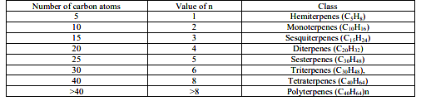
Figure 2.1 Classification of Terpenes (Mabou et.al, 2021)
Amongst the clases of terpenes, sesquiterpenes and oxygenated terpenes stand out for their biological activity. Sesquiterpenes like artemisinin have antimalarial effects, while oxygenated terpenes like menthol and camphor have analgesic and antibacterial qualities. Terpenes modulate enzyme activity and cell signalling pathways, among other biochemical processes, to mediate their therapeutic qualities.
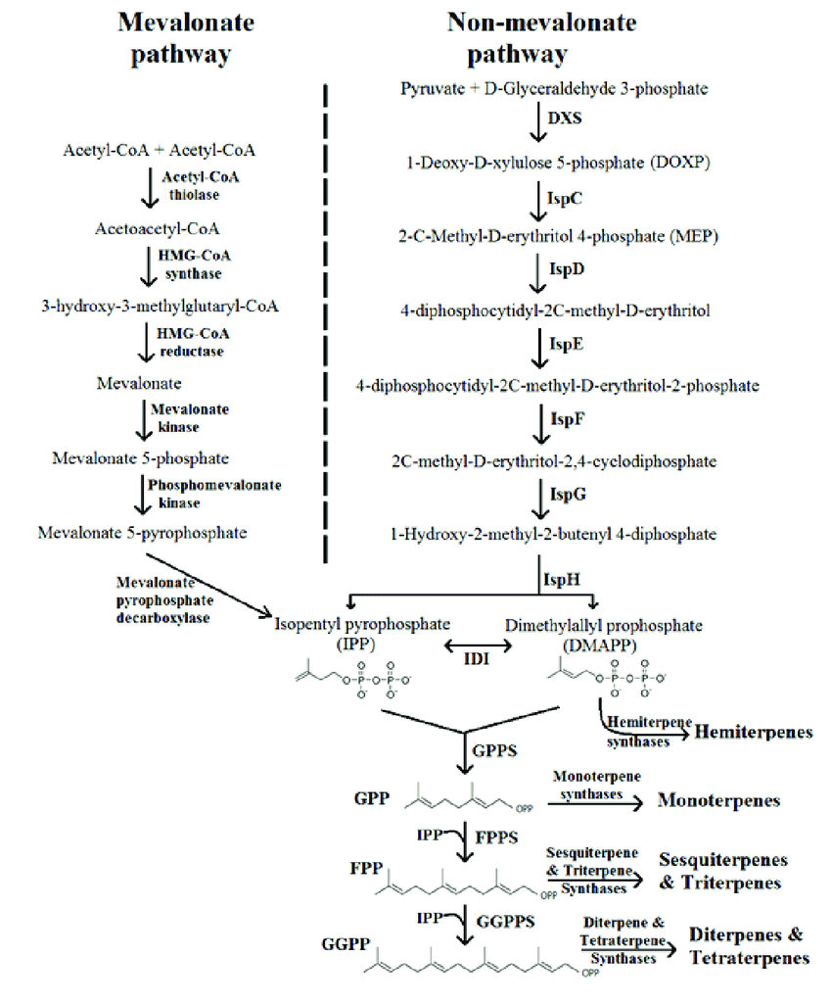
Figure 2.2: Schematic Representation of Terpene Biosynthesis (Abdallah & Quax, 2017)

2.2.3 Phenolics
Phenolics, also known as phenolic compounds, form a heterogeneous cluster of secondary metabolites that are characterized by the presence of one or more hydroxyl groups attached to an aromatic ring. First extracted from coal tar in 1834 by the German chemist, Friedlieb Ferdinand Runge, phenolics are renowned for their antioxidant properties, attributed to their ability to donate hydrogen atoms or electrons to free radicals, thus preventing oxidative damage. Phenolics can be categorized based on their chemical structure into several subclasses, including flavonoids, phenolic acids, lignans, and stilbenes, amongst which, flavonoids are the most abundant and biologically active phenolic compounds, known for their diverse pharmacological effects, including anti-inflammatory, antimicrobial, and anticancer properties (Nimse & Pal, 2015).
Phenolic compounds are synthesized via the shikimate and phenylpropanoid pathways. The shikimate pathway serves as a feeder pathway, synthesizing aromatic amino acids that are precursors for the synthesis of phenolics via the phenylpropanoid pathway. The synthesis of phenolic compounds in plants can be affected by environmental conditions and stressors, leading to differences in phenolic compound composition in plants of the same species, or even differences in the phenolic compound composition of the same plant at different time frames. Specifically, the synthesis of phenolic compounds in plants have been discovered to be upregulated in unfavourable conditions such as; high temperatures, UV radiation, drought, or pathogen attacks.
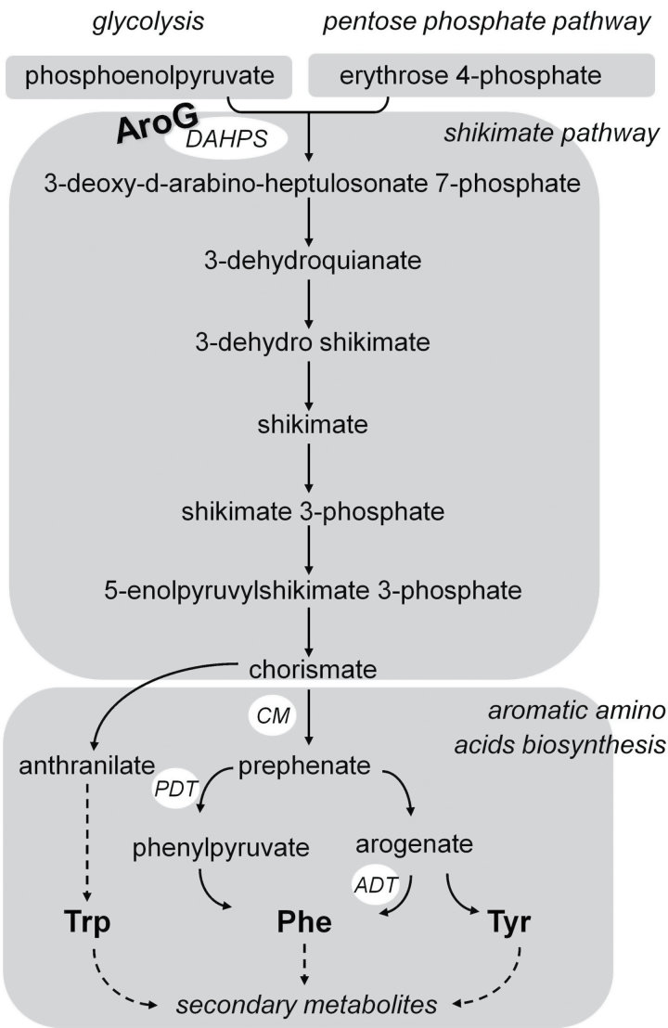
Figure 2.3: The Schikimate pathway (Tzin et al., 2013)
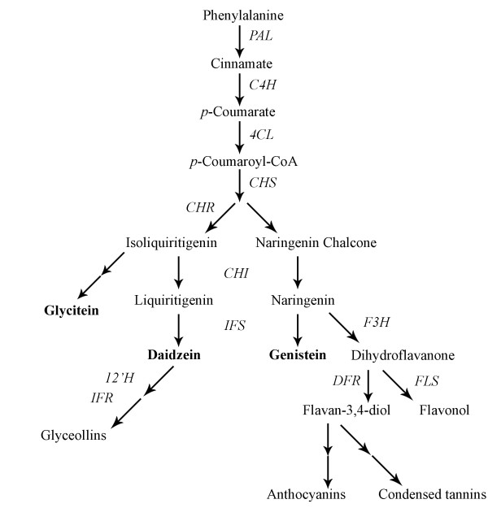
Figure 2.4: The phenylpropanoid pathway (Gutierrez-Gonzalez et al., 2010)

2.2.4 Glycosides
The initial glycoside, amygdalin, was found in bitter almond in 1803 by Schrader, isolated in 1830 by French chemists Pierre Robiquet and Antoine Boutron-Charlard, and finally structurally depicted in 1923 by chemists Haworth and Wylam, unveiling the structure of glycosides as compounds where a sugar (glycone) is linked to an aglycone via O-, N-, S-, or C glycosidic bonds (Spanoudaki et al., 2023).
Glycosides are structurally made up of a sugar group bound to an aglycone, with variations in the sugar units and sequence, aglycone, macrolactone site, and acylated residues. They are formed through glycosylation, which involves the transfer of a sugar moiety from a substrate to an acceptor molecule, resulting in increased polarity of hydrophobic metabolites, increased stability of metabolites, or neutralisation of toxic molecules for improved biodistribution, transport, and metabolism (Kytidou et al., 2020).
These chemicals, such as cyanogenic glycosides present in over 2,500 plant species, have economic value due to their therapeutic qualities such as cytotoxicity, antiviral activities, and plant defence mechanisms, highlighting their potential in pharmaceutical and biological applications (Hollman, 1985; Glycoside, 2024; WHO, 2023).

2.3 Factors Affecting Phytochemical Profiles
These factors encompass the reasons for phytochemical variability, although they may not be easily isolated and identified as the contributing factors to phytochemical instability. Instead, they often occur interwoven, leading to specific compound variation such as isomerism or synergistic reactions while maintaining the overall presence or absence of phytochemical classes.
2.3.1 Plant factors: The phytochemical content of a plant can vary based on its maturity and genetic composition. Environmental factors, such as climate change and stress, can also influence the production of these compounds. The part of the plant chosen for extraction (e.g., leaf, stem, root) can also affect the phytochemical profile (Moomin et al., 2023).
2.3.2 Storage conditions: The conditions under which plant materials are stored can significantly impact their phytochemical content. Prolonged storage times, exposure to light, and exposure to oxygen can all contribute to the degradation of these compounds (Bitwell et al., 2023).
2.3.3 Extraction methods: The methods used to process plant materials and extract their phytochemicals can also affect their phytochemical profiles. Different extraction methods (e.g., solvent extraction, steam distillation, cold pressing) can yield different profiles of compounds (Altemimi et al., 2017).

2.4 Essential Oils
Essential oils are concentrated liquids extracted from plants that generally contain complex mixtures of volatile organic compounds including mostly terpenes, alcohols, esters, ketones, and phenols that contribute to the distinctive aroma and therapeutic potentials of individual essential oils (Herman et.al, 2019). The term essential oil was orginally described by Paracelsus von Hohenheim in the 16th century as Quinta essential, containing highly conserved plant volatiles with specific distribution across plant species that serve a variety of functions such as pollinator-attracting aromas, flavour enhancers, preservatives, and aroma therapy (Pichersky et al., 2006). Essential oils can be found in various apical parts of plants such as leaves, roots, flower buds, barks, seeds, and peels with each having generally different essential oil yeilds in the order; flower buds, then leaves, followed by seeds, barks, roots, and finally peels. Essential oils are typically extracted through methods such as steam distillation, cold pressing, solvent extraction, rotary evaporation, hydrodistillation, and hydrolyzation. However, extraction methods such as steam distillation and hydrodistillation are used industrially to optimize essential oil yeilds from raw plant materials. Figure 1 below depicts the various methods of essential oil extraction.
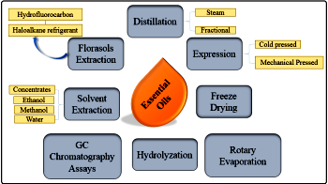
Figure 2.5: Methods of essential oil extraction and isolation (Herman et.al, 2019)

2.4.1 Volatile compounds
Volatile phytochemical compounds, also known as biogenic volatile organic compounds (BVOCs), are lipophilic products, primarily isoprenoids (hemiterpenes, monoterpenes, irregular acyclic homoterpenes, and sesquiterpenes), in response to environmental stimuli such as herbivore attacks or other stressors. BVOCs could also include low-molecular-weight molecules, like oxygenated compounds and fatty acid derivatives, that are involved in constitutive and inducible plant responses to plant physiology and ecosystem interactions (Antonelli et al., 2020).
Apart from their role in plant stress adaptation, BVOCs also have broader ecological implications, as seen with forest VOCs, a subset of BVOCs emitted by trees that have been shown to influence interplant communication, exhibit antimicrobial and insecticidal properties, and impact animal feeding behaviours (Jerković et al., 2018; Negro et al., 2021).
2.4.2 Industrial Uses of Volatile Compounds
2.4.2.1 Insectcidal volatile compounds: In a study by Yang et al. ( 2020), a variety of essential oils were tested and compared against a standard commercial product, for their potency in inducing lethal toxicity in maize weevil through contact and fumigation methods. Amongst the essential oils tested, cinnamon oil and tea tree oil showed high fumigant toxicity, while peppermint and lavender oil showcased notable contact toxicity. Further investigations using elimination methods identified the volatiles, terpinen-4-ol and trans-cinnamaldehyde as the active fumigant in tea tree oil and cinnamon oil respectively. The results of this study, however, identified cinnamon oil to be the only oil showcasing high toxicity potency when administered to maize weevil via contact and fumigation methods (Yang et al., 2020).
2.4.2.2 Mouth wash formulation: Essential oils have been studied for their potential in managing halitosis, commonly known as bad breath. A research study by Masriadi et al. (2021) explored the effectiveness of a herbal mouthwash formulated from extracts of ginger and lemongrass in managing halitosis. The combination of these natural ingredients showed promise in combating bad breath by effectively inhibiting the growth of microbes found in cavities, Pgingivalis and Strptococusmutans. The herbal formulation could prove potent in managing halitosis, with citral from lemongrass and gingerol from ginger potentially inhibiting microbial growth, while aromatics such as menthol from lemongrass contribute to freshening breath (Masriadi et al., 2021; Sarnes et al., 2020).
2.4.2.3 Cosmetics and fragrance production: Clove essential oil is known for its strong, spicy aroma, which makes it a popular choice for fragrance and perfume production. It is often used in combination with other essential oils to create complex and balanced fragrances. For example, clove essential oil is used in the fragrance oil blend "Orange & Lemongrass Fragrance Oil" by Pure Scented, which has a rich aroma with warm cinnamon, cloves, and crushed ginger (Matthews, 2024; Ogwuda et al., 2022).
Ginger essential oil is another essential oil that is used in fragrance production. Its warm, spicy aroma makes it a popular choice for fragrances that are meant to be warm and inviting. For example, ginger essential oil is used in the "L'Homme Fragrance Oil" by YSL, which is a warm and elegant woody infusion with aromatic nuances of freshly sliced ginger, enhanced by bergamot and sparkling lemon (Matthews, 2024; Adeyeoluwa, 2023).
Essential oils are also used in soap-making due to their fragrance and antibacterial properties. They are added to the soap mixture during the saponification process, which converts the fatty acids in the soap into salts, creating a product that is effective in cleaning and deodorizing. Peppermint essential oil possess menthol and is commonly used in soaps due to its fresh, minty, and cooling effects (Sarkic & Stappen, 2018).

2.4.3 Therapeutic Benefits of Volatile Compounds:
Volatile compounds in plants offer numerous therapeutic benefits, including antimicrobial, antifungal, antiviral, anti-hyperglycemic, anti-inflammatory, and antiparasitic effects. They also possess antioxidant, anticancer, and anti-inflammatory properties, aiding in disease prevention and treatment. These compounds also positively impact the immune system and improve physical and mental health (De Lacy Costello et al., 2023; Aguiar et al., 2021).

2.4.3.1 Aroma therapy:
Aromatherapy, a practice utilizing essential oils extracted from plants, has a rich history dating back thousands of years. Essential oils, derived from various plant parts, possess unique properties that can aid in stress relief, pain management, improved sleep, and more (Farrar & Farrar, 2020). René-Maurice Gattefossé pioneered modern aromatherapy in 1928, discovering the healing properties of lavender oil, leading to further exploration of essential oils for treating various conditions (Shah et al., 2010). Despite the lack of scientific proof, aromatherapy is believed to positively impact mental, emotional, and physical health by influencing the limbic system in the brain (Lis-Balchin, 1997). Aromatherapy offers benefits such as stress relief, relaxation, pain management, improved sleep, and immune system support, with studies showing positive results in areas like reducing anxiety in dementia patients, treating acne with tea tree oil, and addressing hair loss with oils like thyme and rosemary (Cao et al., 2023).
Safety precautions are advised due to the potential for allergic reactions or sensitivities, especially for vulnerable populations, making proper dilution and application methods essential for the safe use of essential oils (Farrar & Farrar, 2020).

2.4.3.2 Antioxidant volatiles: D-limonene, a monocyclic monoterpene found in citrus fruits, has been found to exhibit potent antioxidant properties through various mechanisms, such as enhancing the activity of the enzymes Superoxide Dismutase (SOD), Catalase (CAT), and Glutathione Peroxidase (GPx), which play a vital role in neutralizing reactive oxygen species (ROS) and protecting cells from oxidative stress (AlSaffar et al., 2022; Rehman et al., 2014). Additionally, the in-vitro study by Bai et al. showed that d-limonene can effectively protect the lens epithelial cells from apoptosis caused by H2O2-induced oxidative stress by inhibiting ROS generation, caspase-3/caspase-9 activation, p38 MAPK phosphorylation, and increasing the Bcl-2/Bax ratio, suggesting its beneficial use for treating cataracts (Bai et al., 2022).
2.4.3.3 Anti-inflammatory volatiles: Volatile compounds found in plants, such as terpenes and terpenoids, have demonstrated anti-inflammatory activities in respiratory inflammation. For example, the essential oil yeild from Cistus albidus L. inhibited lipoxygenase significantly, indicating its potential as a therapeutic agent for respiratory inflammation (Elbouzidi et al., 2024). In another study, the essential oil from Lavandula pedunculata, also known as the downy lavender, was shown to contain terpenes such as 1,8-cineole and camphor that were responsible for significantly decreasing NO production in lipopolysaccharide (LPS)-stimulated microphages, leading to the downregulation of inflammatory pathways, specifically the nuclear factor kappa B (NF-κB) signalling pathway (Zuzarte et al., 2022). Additionally, volatile compounds such as α-pinene have been shown to have bronchodilator effects, which can help alleviate symptoms of asthma (Kim et al., 2020).

2.5 Polyherbal Formulations
Polyherbal formulations, also known as plant blends, refer to the practice of combining multiple herbs in specific ratios to create herbal medicine preparations. This traditional therapeutic strategy, widely utilized in systems like Ayurveda, involves the synergistic use of various medicinal herbs to enhance therapeutic effectiveness. By blending different herbs, polyherbal formulations aim to achieve a more comprehensive and balanced approach to treating illnesses, harnessing the combined benefits of multiple plant components to address health concerns (Parasuraman et al., 2014).

2.5.1 Medicinal applications of plant blends
The use of polyherbal formulations is common in traditional systems of medicine, such as Ayurveda, Chinese medicine, and Unani, and is gaining popularity in modern medicine due to their potential therapeutic benefits attributed to the synergistic interactions between the various phytochemicals present in the individual herbs (Sharma et al., 2022). These interactions can lead to enhanced bioavailability, improved pharmacological activity, and reduced toxicity compared to single herbal formulations (Hussain et al., 2018). Polyherbal formulations can be prepared in various forms, such as tablets, capsules, powders, and decoctions, and are used to treat a wide range of diseases and conditions, including inflammation, oxidative stress, cancer, and neurodegenerative disorders (Bhope et al., 2011; Hosseinzadeh et al., 2015; Karunamoorthi et al., 2012; Aziz et al., 2018; Fokunang et al., 2011). Table 2.1 shows a list of polyherbal formulations sold inNigeria for different bioactivities.

Table 2.1 Common polyherbal formulations in Nigeria
Commercial name | Local name | Scientific names of constituents | Bioactivity
Jedi-Jedi | Agbo Jedi | Pelargonium zonale L.,  Citrus paradisi M., Vernonia amygdalina D., Sorghum  bicolour M., Allium sativum L.,  and naphthalene tablets | Anti-dysentry, anti-diarrhea
Wound healer |  | A.conyzoids, C. scandens and M. villosu | Antimicribial and wound healing
Alomo bitter | Ogun ale | Treculia Africana Decne. Ex Trécul and Khaya ivorensis A. Chev | Man power, Erectile dysfunction, and anti-dysentry
Black Soap | Ose-dudu | Elaeis guineensisA. Chev. Oil, Theobroma cacao, and Honey | Anti-septic, anti-fungal, moisturizer, anti-bacterial
Ciklavit | Ogun romolapa romolese | Cajanus cajan (L.) Millsp | Managing pain crisis in sickle cell
Ruzu Bitters | Okpu n’ike | Uvarie chamae, Curculigo  pilosa and Colocythis citrulli | Anti-diabetic, antioxidant
Fajik Bitters | Egbogi Jedi | assia alata, Citrus medica var. acida (Roxb.), Aloe barbaris, Aloe vera,Cassia angustifolia | Anti-diabetic, antioxidant
Baker Cleanser Bitters | Okpu n’ike | Aloe vera, Acinos ravens,  Chenopodium murale,  Cinnoamomum aromaticum, Citrus aurantifolia and purified water | Anti-diabetic, Anti-  rheumatism, Anti-  inflammatory
Jobelyn | Blood booster | Sorghum bicolour  Moench leaves, Parquetina nigrescens, Harungana madagascariensis, Anacardium occidentale, Waltheria indica | Treatment and  prevention of  stroke, improves general well-  being, and for treating arthritis
Fidson Bitters | Dankaloma | Ginseng, Phyllanthus niruri, Aloe vera, Tephrosia purpurea,  Eclipta alba, Swertia  chirata (Buch-Ham.), Casssia angustifolia, Cinnamomum  zeylanicum | Immune booster, anti-diabetic

(Oloyede et al., 2022)

2.5.2 Phytonutrient Complexes
Phytocomplexes, also known as phytonutrient complexes, are intricate combinations of bioactive compounds found in plants that contribute to their health benefits. These complexes encompass a diverse array of phytochemicals, such as polyphenols, flavonoids, carotenoids, and alkaloids, each with unique biochemical properties. The interactions between bioactive compounds in a phytocomplex, whether through synergy or antagonism, can significantly impact how they are absorbed, distributed, metabolized, and eliminated in the body, ultimately influencing bioavailability and contributing to the overall pharmacological effects of the complex. Phytocomplexes can be formed through various extraction methods that concentrate these phytonutrients from plant sources (Carradori et al., 2020; Arru et al., 2021; Arru et al., 2021).
2.5.3 Phytochemical interactions in polyherbal formulations
Phytochemical interactions in polyherbal formulations refer to the complex interplay of various bioactive compounds from different plant species, which can enhance or modulate the therapeutic benefits of these formulations.
2.5.3.1 Phytochemical synergy: Phytochemical synergy in polyherbal formulations refers to the enhanced therapeutic benefits achieved through the interaction of various bioactive compounds from different plant species. This concept is highlighted in traditional Ayurvedic, Chinese, Unani, and Peruvian practices, where combinations of herbs are used for the management of numerous ailments (Parveen et al., 2021). A study on a polyherbal formulation known as TC-16, consisting of Zingiber officinale var. Bentong, Piper nigrum L., Citrofortunella microcarpa (Bunge) Wijnands, and honey from Apis dorsata, demonstrated synergistic interactions among the herbs, leading to improved antioxidant potential and combating free radicals. The synergistic effect of polyherbal extract-based formulations is associated with enhanced bioavailability of active constituents, amplified therapeutic effects, and reduced toxicity. The adverse effects are neutralized by multiple components present in the extract formulation (Yap et al., 2023; Veeraswamy et al., 2022).
The synergistic interactions in polyherbal formulations can lead to chemical transformations of active constituents, as observed in the polyherbal formulation Amruthotharam Kashayam. The chromatographic profiling and spectrophotometric studies revealed that the chemistry of the finished formulation is different from that of individual plant extracts. The specific spectral shift observed in Fourier transform infrared spectroscopy (FTIR) analysis and tandem mass spectroscopic studies confirmed the chemical transformations happening during the preparation of Amruthotharam kashayam (Sulaiman et al., 2021).
2.5.3.2 Phytochemical antagonism: Phytochemical antagonism in a polyherbal formulation occurs when the combined effect of two or more herbs is less than the sum of their individual effects, leading to a reduced overall therapeutic potential. This phenomenon can be attributed to the complex interactions between various bioactive compounds present in the herbs, which can either enhance or inhibit each other's activity (Mussarat et al., 2021).
One example of phytochemical antagonism in a polyherbal formulation is observed in a study evaluating the phytochemicals and antioxidant potential of a new polyherbal formulation TC-16. The study found that the antioxidant activity of the formulation was not always additive, indicating the presence of antagonistic interactions among the herbs. Specifically, the combination of Curcuma longa L., Zingiber officinale var. Bentong, Piper nigrum L., Citrofortunella microcarpa (Bunge) Wijnands, and Apis dorsata honey did not always result in a synergistic or additive effect (Yap et al., 2023). Similarly, a study investigating the phytochemical and antioxidant activities of a polyherbal formulation (PHF) from selected medicinal herbs found that the IC50 value of the extract was higher than that of standard ascorbic acid and tocopherol, suggesting a lower antioxidant potential (CO, 2023).

2.5.4 Toxicity concerns of polyherbal formulations
Polyherbal formulations require thorough evaluation to ensure safe and effective use, with dosing being a critical factor in determining toxicity. Interactions between phytochemicals present in different herbs of formulations can impact toxicity, necessitating comprehensive studies to assess safety and precise dosing to prevent adverse effects (Ishtiaq et al., 2017; Abutaha et al., 2020).
The pharmacokinetics of constituent phytochemicals, which govern the absorption, distribution, metabolism, and excretion of these compounds, can also play a role in their toxicity. Understanding the pharmacokinetic behaviors of polyherbal formulations is crucial for predicting safety and potential interactions with other medications (Singh & Ilango, 2024). Processing methods and herb compatibility can also influence toxicity, highlighting the importance of standardized techniques for safety (Shan et al., 2020). A holistic approach is needed to enhance the safety and efficacy of polyherbal formulations, considering dosing, pharmacokinetics, herb interactions, and processing methods.
2.6 Polyherbal formulations from Syzgium aromaticum, Ocimum gratissimum, Zingiber officinale Roscoe, and Cymbopogon citratus
Polyherbal formulations from Syzygium aromaticum, Ocimum gratissimum, Zingiber officinale Roscoe, and Cymbopogon citratus have been studied for their potential health benefits, particularly in the context of volatile compounds and essential oils. These herbs are known for their antioxidant, immunomodulatory, and anti-inflammatory properties, and their essential oils have been shown to have various bioactivities, such as antimicrobial, antioxidant, and antileishmanial effects.
For example, a study found that a polyherbal formulation containing Syzygium aromaticum, Ocimum gratissimum, and Zingiber officinale reduced the parasite load in mice orally inoculated with Trypanosoma cruzi II, suggesting its potential as a source for new antileishmanial drugs (Sarto et al., 2021). Another study on different blends containing Syzygium aromaticum, Ocimum gratissimum, Zingiber officinale Roscoe, and Cymbopogon citratus assessed their antimicrobial, antioxidant, and anticancer properties, providing valuable insights into the potential health benefits and bioactivities of these herbal blends (Mussarat et al., 2021).

2.6.1 Syzgium aromaticum (clove)
The clove tree, scientifically known as Syzygium aromaticum, is a perennial tree belonging to the Myrtaceae family, standing tall at heights of 8–12 metres. The clove tree offers a variety of economical advantages; its flower buds, when dried, have been exploited for their rich flavour and aroma in culinary applications, clove essential oils extracted from its buds find application in the fragrance industry for the making of perfumes, soaps, and cosmetics, clove buds have also been found to hold high therapeutic efficacy as they are rich in the phenolic compound eugenol that offers antioxidant, anti-inflammatory, and antimicrobial properties. Clove trees, as hardwood trees, can yield durable furniture and may serve as firewood for cooking in rural settlements.
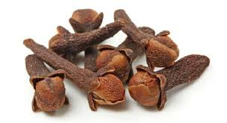
Figure 2.6: Clove buds (Kamatou et al., 2012)
Clove trees produce clusters of delicate pink flower buds, esteemed for their aromatic nature, that have been the subject of scientific interest in attempts to unravel and investigate the mechanisms underlying their medicinal applications. Such scientific investigations include phytochemical screening of cloves aimed at identifying and isolating the biologically active components that mediate therapeutic responses, experimental models testing the efficacy of cloves in the mitigation of inducible disease conditions, as well as bioinformatic analysis of the potential pharmacodynamics that result in therapeutic responses (Ogwuda et al., 2022; Niazi et al., 2022; P, 2022).

2.6.1 Summary of studies on phytochemical composition of Syzgium aromaticum (clove) essential oil
Clove in its dried form is used as a condiment in food preparation, primarily as an aroma and flavour enhancer. Aside from its culinary benefits, clove has been found to possess therapeutic activities and is a medicinal plant utilized across the world for its antimicrobial, antiviral, analgesic, and anesthetic properties. Various qualitative phytochemical analysis carried out on clove extract revealed the presence of a vast spectrum of secondary metabolites in major and minor concentrations, and by comparative investigation of various documented literatures, there have been observable variations in the phytochemical profiles of clove extracts due to dependent variables such as plant and environmental factors, and independent variables such as methods of extraction., as observed in the variations in phytochemical profiles of clove essential oil extracts carried out by Ogwuda et al. (2022) and Utami et al. (2019), with both studies carrying out the extraction of clove essential oil by steam distillation and discovering different phytochemical compositions upon phytochemical screening. Ogwuda et al. (2022) discovered the presence of four major compounds in clove extracts, namely: Benzofuran-2-methyl, Caryophyllene, trans-Isoeugenol, and Caryophyllene oxide, while Utami et al. (2019) identified Eugenol 88.20%, Alpha Copaene 0.49%, Caryophyllene 3.77%, Alpha Humulene 0.48%, Eugenyl acetate 6.76%, and Caryophyllene Oxide 0.30% as the major phytoconstituents of clove oil extract. Under the assumption that the extraction of clove essential oils in these studies was carried out according to standard procedures, the differences in phytochemicals can be associated with other factors such as variations in sample maturity and genetic makeup, as well as physical factors such as heat that favour the isomerization of Eugenol to trans-Isoeugenol.
Another comperative argument can be established by analyzing differences in phytochemical profiles of clove essential oils obtained via different extraction methods, as seen in studies where clove essential oil extraction was carried out by Muwaffaq & Supriyo (2021) and Alighiri et al. (2018) using soxhletion and steam distillation, respectively. The results of the phytochemical screening of clove essential oil extracted by Muwaffaq & Supriyo (2021) using the solvent isopropyl alcohol in a soxhlet procedure indicated the presence of phytochemicals such as eugenol, phenol, β-caryophillene, cycloheptane, allopurinol, dimethylamino, methyl slicylate, caryophillene, cubebene, thienylcyclohexene, and yophyllene oxide, while the results reported by Alighiri et al. (2018) on the phytochemical screening of steam distillation extracted clove essential oil indicated the presence of eugenol, caryophyllene, and humulene in high abundance. This comparison highlights the influence of solvent extraction on phytochemical profiles, with an increased prevalence of oxidized compounds in the study carried out by soxhlet extraction.

2.6.2 Ocimum gratissimum (Scent Leaf)
Scent leaf, scientifically known as Ocimum gratissimum, is a versatile plant with significant medicinal properties. Belonging to the Lamiaceae family, this herbaceous plant is native to Africa, particularly West Africa, where it is commonly used as a culinary herb and for its medicinal benefits. Ocimum gratissimum is also referred to as African basil, basil-clove, or alfavaca. It is characterized by its aromatic nature, with slender, ovate to ovate-lanceolate leaves that have crenate to serrate edges. This plant can grow up to approximately two meters in height, featuring woody main stems that branch into a sub-shrub.
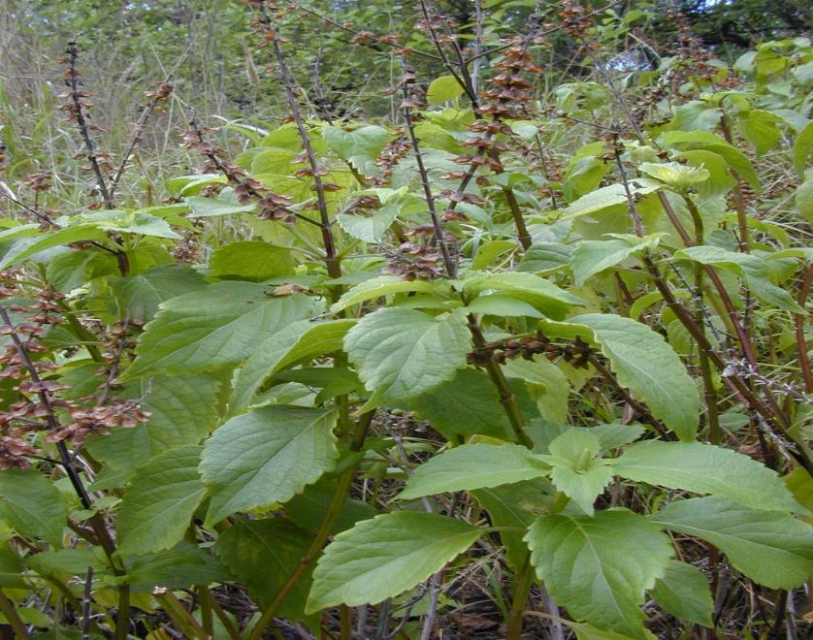
Figure 2.7: (Ocimum Gratissimum, 2024)
In terms of its biological classification, Ocimum gratissimum is part of the genus Ocimum, which comprises about 60 species, most of which are found in Africa. The species name "gratissimum" specifically identifies this plant within the Ocimum genus. This plant is widely distributed in tropical regions such as Brazil, India, Nigeria, Cameroon, and South Africa.The essential oil extracted from Ocimum gratissimum is a complex mixture of volatile organic compounds (VOCs) that contribute to its distinct aroma. This essential oil has various applications in culinary, cosmetics, medicinal, and fragrance industries. Studies have highlighted the antibacterial, anti-inflammatory, and immune-boosting properties of saponins present in scent leaf, making it a valuable natural remedy for a range of health issues. Additionally, the plant has been investigated for its gastro-protective properties, wound healing abilities, and its effectiveness against ulcers induced by various factors.Overall, scent leaf, Ocimum gratissimum, stands out not only for its culinary uses but also for its rich phytochemical composition that offers a wide array of therapeutic benefits, making it a valuable plant in traditional medicine and modern pharmacology (Prabhu et al., 2009; Gurav et al., 2021; Edo et al., 2023; Ugbogu et al., 2021).

2.6.2.1 Summary of studies on phytochemical composition of Ocimum grastissium (scent leaf ) essential oil.
Scent leaf is a herbal plant that is utilized for its anti-microbial, anti-inflammatory and other medicinal attributes, it contains bioactive compounds such as eugenol, thymol, and rosmanic acid that have shown anti-inflammatory, anti microbial, and anti-viral properties (Edo et al., 2023; Hamma et al., 2020).The analysis of ethanolic essential oil extract of O. gratissimum using liquid chromatography-mass spectrometry (LC-ESI–MS/MS) revealed Eugenol (65.135%), Ocimene <(Z) -b-> (7.20%), Caryophyllene <E-> (6.64%), and Germacrene D (12.03%) as the main components (Venuprasad et al., 2014). Phytochemical analysis of O. gratissimum using LC-ESI-MS/MS and other studies have identified a wide range of phytochemicals, including flavonoids, polyphenols, and volatile compounds like eugenol, thymol, and γ-terpinene (Joshi, 2013). The essential oil of O. gratissimum collected in Cameroon is mainly composed of thymol (30.5%) and γ-terpinene (33.0%) (Koba et al., 2008). Another study on the chemical composition of O. gratissimum essential oil from Togo revealed that the oil is rich in thymol (30.5%) and γ-terpinene (33.0%) (Koba et al., 2008).
The essential oils of the flowering aerial parts of two Ocimum species, O. gratissimum and O. sanctum, were analyzed by gas chromatography and gas chromatography/mass spectroscopy. The principal constituent of O. gratissimum and O. sanctum was eugenol (75.1%) and methyl eugenol (92.4%), respectively (Joshi, 2013). The antimicrobial and antioxidant activities of the essential oils of O. gratissimum, O. sanctum, and their major constituents were also screened . The essential oil of O. gratissimum was highly active against S. marcescens, while O. sanctum oil showed significant activity against A. niger and S. faecalis. Methyl eugenol exhibited significant activity against P. aeruginosa, and eugenol was effective only against S. aureus, findings suggesting that eugenol and methyl eugenol from O. gratissimum and O. sanctum could be potential sources of natural food antioxidants, preservatives, and antiseptics (Joshi, 2013).

2.6.3 Zingiber officinale Roscoe (Ginger)
Ginger (Zingiber officinale) is a flowering plant widely utilized as a spice and in traditional medicine. This herbaceous perennial, with slender leaves and a rhizome that emits a strong lemony fragrance, belongs to the Zingiberaceae family. Originating in Maritime Southeast Asia, ginger has a rich history of use by various cultures. Constituent bioactive compounds of ginger, such as gingerols and shogaols, have garnered attention for their nutraceutical properties, showcasing ginger's potential role in various health applications (Kumari et al., 2020).
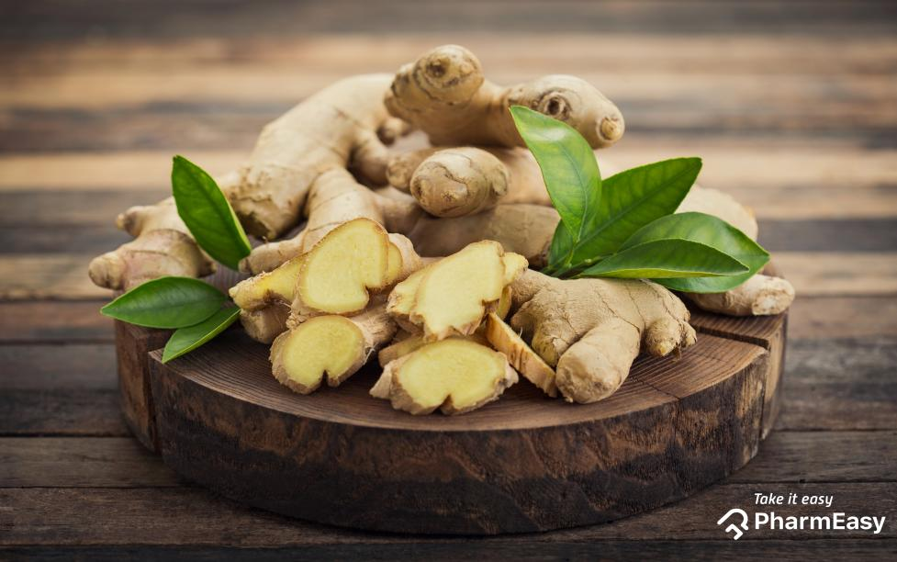
Figure 2.8: Ginger roots (Parmar, 2023)
With over 400 chemical compounds, ginger offers a complex array of bioactive components, its essential oils, including sesquiterpenes like zingiberene and zingerone, contribute to its distinctive aroma and flavour profile. While research suggests potential benefits for mild nausea and vomiting, its efficacy for treating diseases remains uncertain, and its use as a drug is not FDA-approved (Arcusa et al., 2022). Ginger's production, led by India, reached 4.3 million metric tonnes globally in 2020, demonstrating its widespread use as a valuable commodity with health-promoting properties and culinary uses (Zingiber Officinale Roscoe, 2022).
2.6.3.1 Summary of studies on phytochemical composition Zingiber officinale Roscoe (Ginger) essential oil.
Ginger is a spice and herbal plant known to have pharmaceutical and therapeutic applications aside from its common culinary application, credit to the presence of numerous phytochemicals that act as anti-inflammatory, anti-emetic, anti-oxidant, and aphrodisiac agents (Kasi et al., 2016).
The phytochemical screening of the ethanolic extract of Z. officinale carried out by Abu et al. (2023) identified bioactive compounds such as (+)-Borneol, Octanoic Acid, Decanal, Germacrene D, 1,3-Cyclohexadiene, and (E)-1-(6,10-Dimethylundec-5-en-2-y-l). 4-methylbenzene, (E,Z)-alpha, contradicting the discovery documented by Borekar et al. (2018) on the phytochemical screening of ethanolic ginger extract that revealed the presence of 12 major bioactives, namely: isopropenyl dimethyl, 3-Allyl 6 methoxyphenol, Thujaketone, 2 butanoic acid, 2 methoxy methyl, hexahydro farnesol, gingerol, tetradecanoic acid, 1 phenyl 3-6 diazohomoadamantan-9-hydrozone, 7-methyl-2-tetradecen-1-ol-acetate, eicosane, androstan, and squalene.
These phytochemicals can be detected by hydro-distilling oils from powdered ginger powder and then exposing the oil extract to GC-MS analysis (Abu et al., 2023; Oforma et al., 2020). GC-MS analysis of ginger oil extract revealed and confirmed the presence of various bio-active compounds, identifying sesquiterpenes to have the highest concentrations (about 65%), and of the sesquiterpenes, the compound zingiberene was most abundant. Other phytochemicals that could be grouped into specific classes of organic compounds, such as sesquiterpenols, esters, oxides, aldehydes, ketones, monoterpenes, and monoterpenols, were also found present in the ginger oil extracts, but in lower concentrations (Oforma et al., 2020). Kasi et al., (2016), and Oforma et al., (2020) documented the GC-MS analysis of bioactive compounds present in Zingiber officinale.

2.6.4 Cymbopogon citratus (lemongrass)
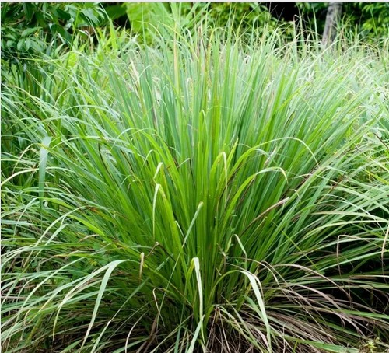
Figure 2.9: Lemongrass (Lemongrass, 2022)
Lemon grass, belonging to the genus Cymbopogon in the Poaceae family, is a plant known for its slender leaves that emit a strong lemony fragrance when touched. This herbaceous plant, native to tropical and subtropical regions of Asia and Africa, includes species like Cymbopogon citratus and Cymbopogon flexuosus, commonly referred to as lemongrass. The characteristic aroma of lemongrass, primarily due to its essential oils like citral, offers a rich lemon flavour without the acidity, complemented by hints of camphor and mint (McDermott, 2019). Used widely in Asian cuisine, lemongrass finds its way into curries, teas, soups, and various dishes such as poultry, seafood, and fish. It is also popular in Latin and African countries for its aromatic properties (Silva & Bárbara, 2022). The therapeutic benefits of lemongrass stem from its anti-inflammatory and antioxidant properties, with compounds like chlorogenic acid, isoorientin, and swertiajaponin aiding in combating inflammation, potentially benefiting conditions like hypercholesterolemia and hypertension (Cheel et al., 2005). Lemongrass tea, known for its health benefits, can help alleviate anxiety, lower cholesterol, prevent infections, and promote oral health (Nida Tabassum, 2020). Additionally, its antimicrobial properties make it effective against pathogenic fungi, enhancing its value in culinary, medicinal, and therapeutic applications globally.
2.6.4.1 Summary of studies on phytochemical compositionof Cymbopogon citratus (Lemongrass) essential oil
The volatile composition of C. citratus (Lemongrass) essential oil has been extensively studied, with a total of 70 volatile compounds identified in one study, accounting for 99.6% of the total composition. The most represented class of volatiles in the essential oil is oxygenated compounds, which account for 86% of the total composition. The major compounds in the essential oil are neral (33.2%) and geranial (39.8%), which are isomers of citral (Pino et al., 2018). Monoterpene hydrocarbons are the second most represented class of volatiles, with myrcene (9.6%) as the predominant compound (Pino et al., 2018).
Other studies have identified a total of 13 compounds from the lemongrass essential oil, accounting for 95.98% of its total composition (Brügger et al., 2019). The primary compounds discovered in the lemongrass oil were neral (31.5%), citral (26.1%), nonan-4-ol (6.54%), camphene (5.19%), 6-metil-hept-5-en-2-one (4.36%), citronelal (3.83%), β-caryophyllene (3.26%), citronelol (2.95%), caryophyllene oxide (2.63%), γ-muurolene (2.46%), limonene (2.32%), geranyl acetate (2.27%), and geranial (2.15%) (Brügger et al., 2019; Onyedikachi et al., 2021).
2.7 Soxhlet Extraction
The Soxhlet extraction method, proposed by Franz von Soxhlet in 1879, is a technique used to extract nonvolatile and semivolatile organic compounds from solid samples such as soils, sludges, and wastes. This method ensures thorough contact between the sample and the extraction solvent, making it suitable for isolating and concentrating organic compounds that are insoluble in water or only slightly soluble. The process involves mixing the solid sample with anhydrous sodium sulfate, placing it in an extraction thimble, and extracting it using an appropriate solvent in a Soxhlet extractor. The extracted material is then dried, concentrated, and transferred to a solvent compatible with subsequent analytical procedures.

2.8 Gas chromatography/mass spectrometry (GC-MS)
Gas Chromatography-Mass Spectrometry (GC-MS) is an analytical technique that combines gas chromatography and mass spectrometry to separate and identify chemical components in a sample mixture. The technique was proposed by Franz von Soxhlet in 1879. In GC-MS, the sample is first vaporized in the gas chromatograph, where it is separated into its individual components based on their boiling points and polarities. These components are then ionized and fragmented in the mass spectrometer, where they are separated based on their mass-to-charge ratios. The resulting data, which includes mass spectra and chromatograms, allows for the identification and quantification of compounds present in the sample. GC-MS provides extensive information on complicated mixtures of substances, making it useful in environmental analysis, food and beverage analysis, forensic science, and pharmaceutical research (Wenzl & Zelinková, 2019; Xu et al., 2021).

CHAPTER THREE

MATERIALS AND METHODS

3.1 Study Location
This research was carried out in Babcock University, Ilishan-Remo, Ogun State, Nigeria.

3.2 Sample collection
The dried cloves (flower buds) were bought from Ilishan central market, Ikenne LGA, Ogun State. Fresh lemon grass were harvested from Trust court estate area, Babcock University, Ilishan-Remo Ogun State. Ginger roots were purchased from Ilishan central market, Ikenne LGA, Ogun State. Fresh scent leaf were harvested directtly from farms located in IIlishan-Remo Ogun State. Table 3.1. shows a list of the selected plant samples.
Table 3.1: Specified plants for sample blends
Scientific name | Common name | Local name | Plant part used
Syzgium aromaticum  Cymbopogon citratus  Zingiber officinale  (Ocimum gratissimum | Cloves  Lemon grass  Ginger  Scent leaf (Basil) | Kanafuru  Kooko oba  Atale  Nchuanwu | Buds  Leaves  Root/Rhizome  Leaves

3.3 Sample Preparation
The dried clove buds were sorted for contaminants and impurities.
The fresh lemon grass were cut into small sizes then spread on a polythene sac bag and shade dried for a period of six days, then further oven dried for 1 hour at a temperature of 70 ºC.
The ginger roots were diced into thin sizes to facilitate drying, air dried for two days, then oven dried at a temperature of 60 ºC for 6 h.
The scent leaves were separated from their branches, shade dried for 4 days then oven dried at a temperature of 60 ºC for 4 h.
All dried samples were ground to a fine powder using a powder grinder, then stored in labeled air-tight plastic containers.

3.4 Equipments and apparatus
Weighing balance was used to accurately measure and record the weight of samples and apparatus. Oven was used for drying apparatus, samples, and extracts. Soxhlet apparatus was used to extract essential oils from samples. Water bath was used a heat source for the soxhlation of samples. Heating mantle was used as an alternate heat source for the soxhlation of samples. Round bottom flask used for the collection of essential oils produced from soxhlation process. Beakers used to store product of soxhlation till solvent had been completely vaporized. Funnel and filter paper were used together as a unit to facilitate the filtration of essential oil produced from soxhlation processes. 2 mL glass vials were used to store final essential oil yields.

3.5 Solvents/Reagents
All solvents and reagents used were of analytical grades and produced by Molychem. n-hexane was selected as solvent for Soxhlet extraction due to its favorable boiling of 68.7 ºC, which facilitated efficient extraction and drying processes.

3.6 Preparation of samples for soxhlation process

To prepare the first sample mixture, 15 g of ground lemon grass was weighed and mixed with 15 g of ground scent leaf. The resulting mixture was poured, tied and folded in a thin white linen. This mixture was labeled blend A
To prepare the second sample mixture, 7.5 g each of ground lemon grass, scent leaf, clove, and ginger were weighed and mixed together. The resulting mixture was poured, tied and folded in a thin white linen. This mixture was labeled blend B

To prepare the third sample mixture, 10 g of ground lemon grass, clove, and scent leafwe were weighed and mixed. The resulting mixture was poured, tied and folded in a thin white linen. This mixture was labeled blend C
3.6.1 Soxlation process
The extraction of essential oils from samples of interest were carried out using soxhlet apparatus. The sample blend, already tied in a linen, were inserted into the extraction chamber. The Soxhlet apparatus was assembled, including a round-bottom flask, extraction thimble, condenser, and refluxing siphon. 250ml n-hexane was poured from atop the condenser by aid of a funnel. The coupled apparatus was fixed into water bath supported and was by a retort stand. The temperature of the water bath was set at 76.5ºC.
The extraction was monitored, and parameters such as extraction time and solvent volume were adjusted as needed to optimize yield and efficiency. The extraction was carried out for 12 h. Once the extraction was complete, the round-bottom flask containing the extracted solution was removed from the heating mantle and allowed to cool. The extracted solution containing the dissolved compounds was recovered by carefully decanting and evaporating the solvent under reduced pressure. The essential oil yield was stored in sample vials. Finally, the Soxhlet apparatus was disassembled, cleaned thoroughly, and stored properly for future use, and waste materials were disposed of according to established safety guidelines and regulations.

3.7 Sample preparation for GC-MS analysis
The essential oil yeilds were stored in a 2 mL glass vials for transportation to the Labwox, Ikeja, Lagos where the GC-MS caharacterization of aromatic-active compounds (AACs) was carried out.
3.8 GC-MS analysis

GC Specifications

Gas chromatography (GC) analysis of the oil samples was performed using 8890A gas chromatograph coupled to 5977C inert mass spectrometer with electron impact source (Agilent Technologies). The stationary phase of separation of the compounds was carried out on HP‐5 capillary column coated with 5% of Phenyl Methyl Siloxane (30 m length × 0.32 mm diameter × 0.25 μm film thickness). Hydrogen was the carrier gas at a constant flow rate of 1.4871 mL/min, an initial nominal pressure of 3.21 psi and at an average velocity of 45.079 cm/sec. One microliter of the samples was injected with 10:1 Split mode at an injection temperature of 300 °C. Purge flow was 21.5 mL/min at 0.50 min with a total gas flow rate of 23.355 mL/min; gas saver mode was switched on.
The oven was initially programmed at 80°C (1 min), then ramped at 17 °C/min to 310 °C (10 min). Run time was 23.52 minutes with a 3 min solvent delay.
MS Conditions
The mass spectrometer was operated in electron‐impact ionization mode at 70eV with
ion source temperature of 230 °C, quadrupole temperature of 150°C and transfer line
temperature of 280 °C. Scanning of possible compounds was from m/z 50 to 550 amu at 2.62s/scan rate and were identified by comparing measured mass spectral data with
those in NIST 14 Mass Spectral Library.

CHAPTER FOUR

RESULTS
4.1 Levels of aromatic active compounds (AACs) in lemongrass
The soxhlation of 30 g of ground lemongrass, yeilded 2 mL of a viscous, dark green extract with a characteristic minty odor, suggesting the presence of aromatic compounds.
Table 4.1 shows the levels of aromatic active compounds (AACs) in n-hexane extract of lemongrass before and after storage. The acyclic monoterpene aldehyde, Citral, was the only volatile compound identified in the n-hexane extract of lemongrass before storing. The most abundant volatile compounds found after storage were eugenol, phenol, 2-methoxy-4-(2-propenyl)-, acetate, and 5-Hydroxy-1-(4-hydroxy-3-methoxyphenyl)decan-3-one with area percentages 64.13 %, 10.20 %, and 6.05 % respectively.
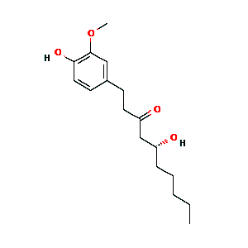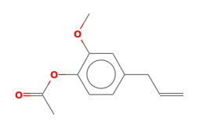
Figure 4.2: phenol, 2-methoxy-4-(2-propenyl)-, acetate (NIST, 2023)
Figure 4.1: 5 Hydroxy-1-(4-hydroxy-3-
methoxyphenyl)decan-3-one

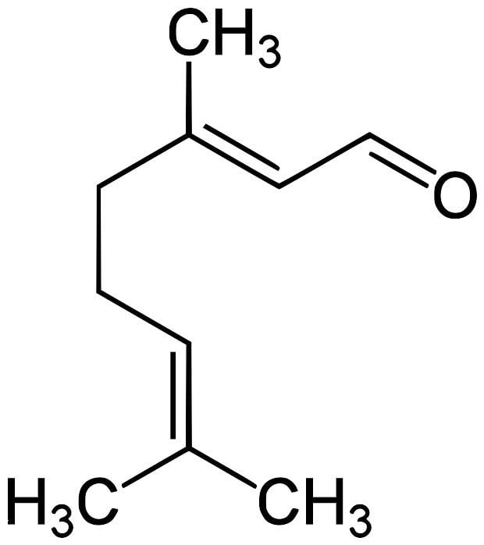
Figure 4.3: Citral (Alam et al., 2018)

Table 4.1: Levels of aroma-active compounds (AAC) in n-hexane extract from lemongrass before and after storage

S/N | Retention Time | Name of compound | Area (%) before storage | Area (%) after storage | Quality | Cannonical smile
1 | 7.296 | Citral | 13.10 |  | 97 | CC(C)=CCCC(C)=CC=O
2 | 7.401 | Thymol |  | 1.40 | 90 | CC1=CC(=C(C=C1)C(C)C)O
3 | 8.008 | Eugenol |  | 64.13 | 97 | C=CCc1ccc(O)c(OC)c1
4 | 8.531 | Caryophyllene |  | 5.57 | 99 | CC1CCC2C(C1)CCC3C2CCC4C3(CCC(C4)C)C
5 | 8.793 | Humulene |  | 0.66 | 97 | CC1CCC2C(C1)CCC3C2CCC4C3(CCC(C4)C)C
6 | 9.013 | 1,3-Cyclohexadiene, 5-(1,5-dimethyl-4-hexenyl)-2-methyl-, [S-(R*,S*)]- |  | 1.36 | 87 | [C@H]1CCC[C@@H]2[C@@H]1CCC(C2)C(C)C
7 | 9.254 | Phenol, 2-methoxy-4-(2-propenyl)-, acetate |  | 10.20 | 97 | CC(=O)OCc1ccc(OCC=C)cc1OC
8 | 10.133 | 2-Butanone, 4-(4-hydroxy-3-methoxyphenyl)- |  | 1.11 | 96 | COc1cc(ccc1O)C(=O)CC
9 | 13.882 | 1-(4-Hydroxy-3-methoxyphenyl)dec-4-en-3-one |  | 2.47 | 96 | COc1cc(ccc1O)C(=O)C=CCC
10 | 14.091 | 1-(4-Hydroxy-3-methoxyphenyl)decane-3,5-dione |  | 1.00 | 92 | COc1cc(ccc1O)C(=O)CC(=O)C
11 | 14.395 | 5-Hydroxy-1-(4-hydroxy-3-methoxyphenyl)decan-3-one |  | 6.05 | 99 | COc1cc(ccc1O)C(=O)CC(O)C
12 | 16.038 | 1-(4-Hydroxy-3-methoxyphenyl)tetradecane-3,5-dione |  | 2.32 | 94 | COc1cc(ccc1O)C(=O)CC(=O)CCCC

4.2 Levels of aromatic active compounds (AACs) in blend A
The soxhlation of 30g of blend A yeilded about 3 mL of a dark green extract with a complex characteristic smell. After careful sensory evaluation of the aroma of the extract, it was discovered that the distinct aroma of Scent leaf was predominant, suggesting a greater abundance of Scent leaf aromatics.
Table 4.2 shows the levels of aromatic active compounds (AACs) in n-hexane extract of blend A, a polyherbal formulation containing scent leaf and lemongrass. In the order of abundance, Thymol, Citral, o-Cymene & p-Cymene, Naphthalene, decahydro-4a-methyl-1-methylene-7-(1-methylethenyl)-,[4aR(4a.alpha.,7.alpha.,8a.beta.)], and, .gamma.-Terpinene, were identified as constituents of blend A. Furthermore, Thymol and Citral were the most abundant, with the percentage abundances 37.05 %, and 19.03 % respectively.
GC/MS analysis of n-hexane extract of blend A after storage resulted in the separation of 8 volatile compounds namely, P-Cymene, o-Cymene, Thymoquinone, Thymol, Phenol, 2-methyl-5-(1-methylethyl), Eugenol, Caryophyllene, Bicyclo[3.1.1]hept-2-ene, 2,6-dimethyl-6-(4-methyl-3-pentenyl)-, Naphthalene,1,2,3,5,6,7,8,8a-octahydro-1,8a-dimethyl-7-(1-methylethenyl)-, [1R-(1α,7β,8aα)]-, and 1,2-Benzenediol, 3,5-bis(1,1-dimethylethyl)-.
Eugenol, Thymol, and Bicyclo[3.1.1]hept-2-ene, 2,6-dimethyl-6-(4-methyl-3-pentenyl)-, were found to be the volatile compounds with the highest abundance, with the area of abundances 24.60 %, 17.79 % , and 15.56 % respectively.

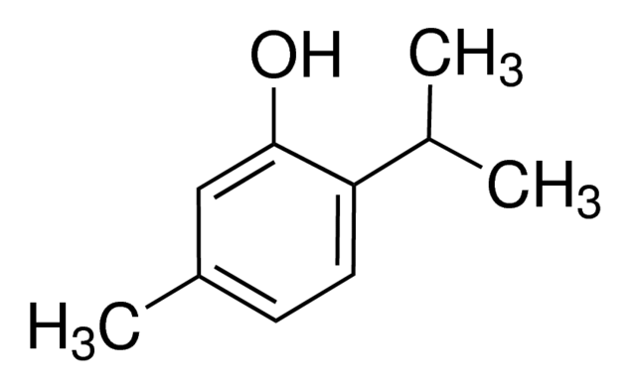
Figure 4.4: Citral (Alam et al., 2018)
Figure 4.5: Thymol (Dong et al., 2020)
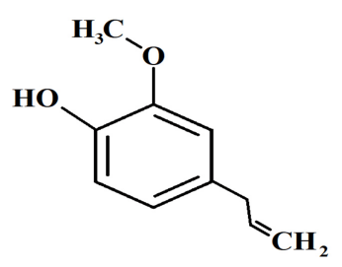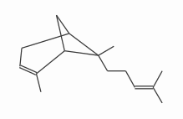
Figure 4.7: Bicyclo[3.1.1]hept-2-ene,2,6-dimethyl-6-(4-methyl-3-pentenyl)- (NIST, 2023)
Figure 4.6: Eugenol (Ulanowska, 2021)

Table 4.2: Levels of aroma-active compounds (AAC) in n-hexane extract of blend A before and after storage

S/N | Retention Time | Name of compound | Area (%) before storage | Area (%) after storage | Quality | Cannonical smile | Class of compound
1 | 5.055 | o-Cymene  p-Cymene | 6.48 |  | 94 | CC1=CC=CC=C1C  CC1=CC=C(C)C=C1 | Monoterpene
2 | 5.003 | p-Cymene  o-Cymene |  | 2.51 | 96  96 | CC1=CC=C(C=C1)C(C)C  CC1=CC=C(C=C1)CC | Monoterpene
3 | 5.380 | .gamma.-Terpinene | 4.76 |  | 95 | CC(C)=CCC1=CC=CC=C1 | Monoterpene
4 | 7.296 | Citral | 19.03 |  | 95 | CC(C)=CCCC(C)=CC=O | Monoterpene  aldehyde
5 | 7.108 | Thymoquinone |  | 5.21 | 97 | CC1=CC=C(C=C1)C(=O)C1=CC=CC=C1 | Monoterpene  Ketone
6 | 7.401 | Thymol  Phenol, 2-methyl-5-(1-methylethyl) |  | 17.79 | 90  90 | CC1=CC=C(C=C1)C(C)(C)O  CC(C)C1=CC(=CC=C1)O | Monoterpene alcohol
7 | 7.442 | Thymol | 37.05 |  | 94 | CC1=CC=C(C(C)C=C1)C(C)(C)O | Monoterpene  alcohol
8 | 7.997 | Eugenol |  | 24.60 | 98 | CC1=CC(=CC=C1CC=C(C)C)O | Phenolic compound
9 | 8.532 | Caryophyllene |  | 9.03 | 98 | CC1CCC2C(C1)CCC3C2CCC4C3(CCC(C4)C)C | Sesquiterpene
10 | 9.013 | Bicyclo[3.1.1]hept-2-ene, 2,6-dimethyl-6-(4-methyl-3-pentenyl)- |  | 15.56 | 89 | CC(=CCC/C(=C/C(CC1CCC1)=C/C(C)C)\C)C | Sesquiterpene
11 | 9.097 | Naphthalene, decahydro-4a-methyl-1 -methylene-7-(1-methylethenyl)-, [4aR-(4a.alpha.,7.alpha.,8a.beta.)] | 5.82 |  | 98 | CC1=CCC2C1CCC2(C)C(C)=CC1=CC=CC=C1 | Sesquiterpene
12 | 9.107 | Naphthalene,1,2,3,5,6,7,8,8a-octahydro-1,8a-dimethyl-7-(1-methylethenyl)-, [1R-(1α,7β,8aα)]- |  | 4.79 | 96 | CC1=CCC2C(CCC3C2CCC2C4CCC@@HCC3(C)C)C1C | Sesquiterpene
13 | 12.866 | 1,2-Benzenediol, 3,5-bis(1,1-dimethylethyl)- |  | 1.79 | 64 | CC(C)(C)C1=CC(=CC(=C1)O)C(C)(C)C | Phenolic compound

4.3 Levels of aromatic active compounds (AACs) in blend B
The soxhlation of 30 g of blend B yeilded about 3 mL of a fine brownish oil with a complex characteristic smell. After sensory evaluation of the aroma of the oil yeild, it was discovered that the scent of cloves was predominant and greately expressed, suggesting the abundance of clove aromatics.
Table 4.3 shows the levels of aromatic active compounds (AACs) in n-hexane extract of blend E, a polyherbal formulation containing clove, scent leaf, lemongrass, and ginger. Citral, Thymol, the isomers Eugenol & phenol, 2-methoxy-3-(2-propenyl), Carophyllene, trans-.alpha.-Bergamotene, 1,3-Cyclohexadiene, 5-(1,5 dimethyl-4-hexenyl)-2-methyl-, [S-(R*,S*)]-, and Phenol, 2-methoxy-4-(2 propenyl)-,acetate, were identified to be major volatiles, having more percentage abundance in sample essential oil. Their percentage abundances are 2.53 %, 4.30 %, 53.25 %, 11.67 %, 6.58 %, and 14.82 % respectively.
Five minor voaltiles were discovered in lower abundance, including the monoterpene oisomers p-Cymene, o-Cymene, & Benzene, 1-methyl-3-(1-methylethyl)-, as well as the sesquiterpenes; Humulene, and Benzene,1-(1,5-dimethyl-4-hexenyl)-4-methyl- with the percentage abundance 0.66 %, 1.29 %, and 1.12 % respectively. Eugenol and phenol, 2-methoxy-3-(2-propenyl) were found to be the volatile compounds with the highest abundance, most probably contributed from the clove constituent of sample blend (Ogwuda et al., 2022).
GC/MS analysis of n-hexane extract of blend B after one month of storage resulted in the separation of 10 volatile compounds namely, Thymoquinone, Phenol, 5-methyl-2-(1-methylethyl)-, acetate, Phenol, 2-methoxy-3-(2-propenyl)-, Eugenol, Caryophyllene, Humulene, Benzene, 1-(1,5-dimethyl-4-hexenyl)-4-methyl-, (R)-1-Methyl-4-(6-methylhept-5-en-2-yl)cyclohexa-1,4-diene, .gamma.-Muurolene, Phenol, 2-methoxy-4-(2-propenyl)-acetate, 2-((2R,4aR,8aR)-4a,8-Dimethyl-1,2,3,4,4a,5,6,8a-, octahydronaphthalen-2-yl)prop-2-en-1-ol. Eugenol and Phenol, 2-methoxy-4-(2-propenyl)-acetate, were found to be the volatile compounds with the highest abundance, with the area of abundances 77.11 %, and 6.81 % respectively.
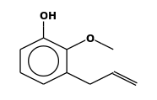
Figure 4.9: Phenol, 2-methoxy-3-(2-propenyl) (NIST, 2023)
Figure 4.8: Eugenol (Ulanowska, 2021)
S/N | Retention Time  Table 4.3: Levels of aroma-active compounds (AAC) in n-hexane extract of blend B before and after storage | Name of compound | Area (%) before storage | Area (%) after storage | Quality | Cannonical smile | Class of compound
1 | 5.056 | p-Cymene  Benzene, 1-methyl-3-(1-methylethyl)-  o-Cymene | 0.66 |  | 92  92  92 | CC1=CC(=CC=C1C)C  CC(C)Cc1ccccc1  CC1=CC(=CC=C1C)C | Monoterpene  Alkylbenzene  Monoterpene
2 | 7.097 | Thymoquinone |  | 0.16 | 98 | CC(C)C1=CC(=O)C=C(C)C1 | Monoterpene  Ketone
3 | 7.296 | Citral | 2.53 |  | 96 | CC(C)=CCCC(C)=CC(=O) | Monoterpene  Aldehyde
4 | 7.401 | Phenol, 5-methyl-2-(1-methylethyl)-, acetate |  | 1.71 | 93 | CC(C)C1=CC(=CC=C1O)C(C)C | Phenolic Ester
5 | 7.443 | Thymol | 4.30 |  | 94 | CC1=CC=C(C=C1)C(C)(C) | Monoterpene Alcohol
6 | 8.039 | Phenol, 2-methoxy-3-(2-propenyl)-  Eugenol | 53.25 |  | 98  98 | COC=CC=C(C=C1)C(O)=C1  OCC1=CC=C(C=C1)CC=C | Phenolic Compound  Phenolic Compound
7 | 8.019 | Phenol, 2-methoxy-3-(2-propenyl)- |  | 77.11 | 97 | C=CCc1cccc(OC)c1O | Phenolic Compound
 |  | Eugenol |  | 77.11 | 97 | C=CCc1ccc(O)c(OC)c1 | Phenolic Compound
8 | 8.532 | Caryophyllene |  | 4.74 | 99 | CC1CCC2C(C1)CCC3C2CCC4C3(CCC(C4)C)C | Sesquiterpene
9 | 8.594 | Carophyllene | 11.67 |  | 99 | CC1CCC2C(C1)CCC3C2CCC4C3(CCC(C4)C)C | Sesquiterpene
10 | 8.793 | Humulene |  | 0.61 | 97 | CC1CCC2C(C1)CCC3C2CCC4C3(CCC(C4)C)C | Sesquiterpene
11 | 8.846 | Humulene | 1.29 |  | 95 | CC1CCC2C(C1)CCC3C2CCC4C3(CCC(C4)C)C | Sesquiterpene
12 | 8.982 | Benzene,1-(1,5-dimethyl-4-hexenyl)-4-methyl- | 1.12 |  | 97 | CCC(=C)CCCC1=CC=C(C)C=C1 | Alkylbenzene
13 | 9.066 | trans-.alpha.-Bergamotene  1,3-Cyclohexadiene, 5-(1,5 dimethyl-4-hexenyl)-2-methyl-, [S-(R*,S*)]- | 6.58 |  | 93  93 | CC(=CCCC1(C)CCC(=C)C1(C)C)C  CC(C)C(C)=CCC1=CCC(=CC1=C)C(C)=C | Cyclohexadiene  derivative  (Terpenoid)
14 | 9.013 | (R)-1-Methyl-4-(6-methylhept-5-en-2-yl)cyclohexa-1,4-diene |  | 4.37 | 83 | CC(=C)[C@H]1CCC[C@@H]2[C@@H]1CCC(C2)C(C)C | Sesquiterpene
15 | 9.118 | .gamma.-Muurolene |  | 0.98 | 93 | CC1=CCC(CC1)C(C)CCC=C(C)C | Sesquiterpene
16 | 9.243 | Phenol, 2-methoxy-4-(2-propenyl)-acetate |  | 6.81 | 96 | CC(=O)OCc1ccc(OCC=C)cc1OC | Phenolic Ester
17 | 9.296 | Phenol, 2-methoxy-4-(2 propenyl)-,acetate | 14.82 |  | 97 | COC(=O)C=CC=C(C=C1)C(O)=C1 | Phenolic Ester
18 | 9.777 | 2-((2R,4aR,8aR)-4a,8-Dimethyl-1,2,3,4,4a,5,6,8a-octahydronaphthalen-2-yl)prop-2-en-1-ol |  | 0.52 | 91 | CC(=C)[C@H]1CCC[C@@H]2[C@@H]1CCC(C2)(C)CO | Terpenoid Alcohol

4.4 Levels of aromatic active compounds (AACs) in blend C
The soxhlation of blend C yielded a dark green extract with a complex aroma. Although the aroma from cloves was detectable, the minty aromas of scent leaf and lemongrass were more prominent upon sensory evaluation. The GC/MS analysis analysis of n-hexane extract from blend C before storage revealed the presence of 23 volatile compounds of various classes. The predominantly recurring classes include monoterpene, monoterpene derivatives, sesquiterpenes, and phenolics. The volatile compounds; Caryophyllene, 1H-Cycloprop[e]azulen-7-ol, decahydro-1,1,7-trimethyl-4-methylene-, [1ar-(1a.alpha.,4a.alpha.,7.beta., 7a.beta.,7b.alpha.)]-, Isoaromadendrene epoxide, and (R,Z)-2-Methyl-6-(4-methylcyclohexa-1,4-dien-1-yl)hept-2-en-1-ol, were the most abundant before storage with the percentage abundances 13.74 %, 8.42 %, 11.97 %, and 8.24 % respectively.
The GC-MS analysis of n-hexane extract from stored formulation of blend C, identified Eugenol (75.62 %), and caryophllene (6.43 %) as the most abundant volatile compounds.

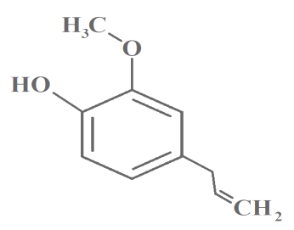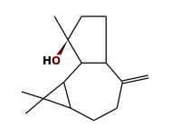
Figure 4.11:1H-Cycloprop[e]azulen-7-ol, decahydro-1,1,7-trimethyl-4-methylene-, [1ar-(1a.alpha.,4a.alpha.,7.beta., 7a.beta.,7b.alpha.)]- (NIST, 2023)
Figure 4.10: Eugenol (Ulanowska, 2021)

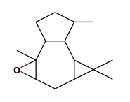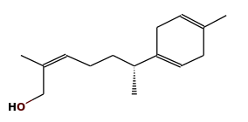
Figure 4.12: Isoaromadendrene epoxide (NIST, 2023)
Figure 4.13: (R,Z)-2-Methyl-6-(4-methylcyclohexa-1,4-dien-1-yl)hept-2-en-1-ol (NIST, 2023)

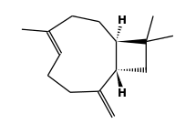
Figure 4.14: Caryophyllene (NIST, 2023)

S/N | Retention Time  Table 4.3: Levels of aroma-active compounds (AAC) in n-hexane extract of blend C before and after storage | Name of compound | Area (%) before storage | Area (%) after storage | Quality | Cannonical smile | Class of compound
1 | 3.338 | Fenchol, exo- | 7.26 |  | 87 | CC1(C2CCC(C2)(C1O)C)C | Monoterpene alcohol
2 | 3.768 | Isoborneol | 1.01 |  | 94 | CC1(C2CCC(C2)(C1O)C)C | Monoterpene alcohol
3 | 3.851 | .gamma.Terpinene | 3.09 |  | 94 | CC1=CCC(CC1)C | Monoterpene
4 | 3.946 | Tricyclo[2.2.1.0(2,6)]heptane, 1,3  ,3-trimethyl- | 0.72 |  | 92 | CC1(C2CCC(C2)(C1)C)C | Tricyclic  sesquiterpene
5 | 5.003 | o-Cymene |  | 0.08 | 93 | CC1=CC=CC=C1C | Monoterpene
6 | 5.369 | Phenol, 2-methoxy-3-(2-propenyl)-  Eugenol | 0.79 |  | 98 | CC=CC1=CC(=CC(=C1)OC)O  CC1=CC(=CC=C1CC=C(O)C)O | Phenylpropanoid
7 | 5.589 | Copaene | 1.24 |  | 99 | CC1CCC2(C1CCC3C2CCC4C3(CCC(C4)C)C)C | Sesquiterpene
8 | 5.684 | (-)-.beta.-Bourbonene | 1.82 |  | 96 | CC1CCC2(C1CCC2(C)C)C | Sesquiterpene
9 | 6.008 | Caryophyllene | 13.74 |  | 97 | CC1CCC2C(C1)CCC3C2CCC4C3(CCC(C4)C)C | Sesquiterpene
10 | 6.280 | Humulene | 1.40 |  | 97 | CC1CCC2C(C1)CCC3C2CCC4C3(CCC(C4)C)C | Sesquiterpene
11 | 6.500 | Germacrene D | 4.30 |  | 95 | CC1CCC2C(C1)CCC3C2CCC4C3CCC5C4CCC(C5)C | Sesquiterpene
12 | 6.626 | 1H-Cyclopropa[a]naphthalene, 1a,2,  3,3a,4,5,6,7b-octahydro-1,1,3a,7-t  etramethyl-, [1aR-(1a.alpha.,3a.al  pha.,7b.alpha.)]- | 3.59 |  | 95 | CC1(C2CCC(C2)(C1)C)C | Cyclopropyl  sesquiterpene
13 | 6.793 | Naphthalene, 1,2,3,5,6,8a-hexahydr  o-4,7-dimethyl-1-(1-methylethyl)-,  (1S-cis)- | 1.34 |  | 99 | CC1(C2CCC(C2)(C1)C)C | Diterpene alcohol
14 | 7.097 | Dehydroelasholtza ketone |  | 0.22 | 80 | CC1(C2CCC(C2)(C1)C)C | Sesquiterpene  ketone
15 | 7.306 | 1H-Cycloprop[e]azulen-7-ol, decahy  dro-1,1,7-trimethyl-4-methylene-,  [1ar-(1a.alpha.,4a.alpha.,7.beta.,  7a.beta.,7b.alpha.)]- | 8.42 |  | 96 | CC1(C2CCC(C2)(C1)C)C | Cyclopropyl  sesquiterpene
16 | 7.380 | Isoaromadendrene epoxide | 11.97 |  | 83 | CC1(C2CCC(C2)(C1)C)C | Sesquiterpene  epoxide
17 | 7.401 | Phenol, 2-methyl-5-(1-methylethyl)  Thymol | 1.47 |  | 90 | CC(C)C1=CC(=CC(=C1)O)C  CC1=CC(=C(C=C1)C(C)C)O | Phenolic  monoterpene
18 | 7.568 | Caryophyllene oxide | 1.93 |  | 83 | CC1CCC2C(C1)CCC3C2CCC4C3(CCC(C4)O)C | Sesquiterpene oxide
19 | 7.757 | 1H-Cyclopropa[a]naphthalene, 1a,2, 6,7,7a,7b-hexahydro-1,1,7,7a-tetra methyl-, [1aR-(1a.alpha.,7.alpha., 7a.alpha.,7b.alpha.)]- | 3.04 |  | 92 | CC1(C2CCC(C2)(C1)C)C | Cyclopropyl  sesquiterpene
20 | 7.882 | Naphthalene, 1,2,3,5,6,7,8,8a-octa  hydro-1,8a-dimethyl-7-(1-methyleth  enyl)-, [1S-(1.alpha.,7.alpha.,8a.  alpha.)]- | 3.25 |  | 97 | CC1(C2CCC(C2)(C1)C)C | Sesquiterpene
21 | 7.997 | Neoisolongifolene, 8,9-dehydro-4,4-Dimethyl-3-(3-methylbut-3-enylidene)-2-methylenebicyclo[4.1.0]heptane | 2.48 |  | 95 | CC1(C2CCC(C2)(C1)C)C | Sesquiterpene
22 | 8.008 | Eugenol |  | 75.62 | 97 | CC1=CC(=CC=C1CC=C(O)C)O
23 | 8.113 | (R,Z)-2-Methyl-6-(4-methylcyclohex  a-1,4-dien-1-yl)hept-2-en-1-ol | 8.24 |  | 64 | CC1=CC(=CC=C1CC=C(C)CCC(C)O)C | Sesquiterpene  alcohol
24 | 8.532 | Caryophyllene |  | 6.43 | 99 | CC1CCC2C(C1)CCC3C2CCC4C3(CCC(C4)C)C
25 | 8.793 | Humulene |  | 0.79 | 97 | CC1CCC2C(C1)CCC3C2CCC4C3(CCC(C4)C)C
26 | 8.929 | Benzene, 1-(1,5-dimethyl-4-hexenyl)-4-methyl- |  | 0.52 | 97 | CC(C)C1=CC(=CC=C1)CC=C(C)C | Phenylpropanoid
27 | 9.013 | 1,3-Cyclohexadiene, 5-(1,5-dimethy  l-4-hexenyl)-2-methyl-, [S-(R*,S*) ]- |  | 1.52 | 87 | CC(C)C1=CC(=CC=C1)CC=C(C)C | Phenylpropanoid
28 | 9.252 | Phenol, 2-methoxy-4-(2-propenyl)-,  acetate |  | 1.56 | 98 | CC(=O)OC1=CC(=CC(=C1)OC)O | Phenylpropanoid
29 | 10.437 | 2',3',4' Trimethoxyacetophenone |  | 0.11 | 86 | COC1=CC(=CC(=C1)OC)C(=O)COC | Phenylpropanoid
30 | 10.688 | 7-Isopropyl-1,1,4a-trimethyl-1,2,3  ,4,4a,9,10,10a-octahydrophenanthre  ne | 4.89 |  | 97 | CC1(C2CCC(C2)(C1)C)C | Steroid
31 | 10.877 | (4aS,4bR,10aS)-7-Isopropyl-1,1,4a- trimethyl-1,2,3,4,4a,5,6,9,10,10a-deca  hydrophenanthrene | 1.71 |  | 99 | CC1(C2CCC(C2)(C1)C)C | Steriod
32 | 12.280 | Imidazolo[1,2-a]pyridine, 6-chloro  -2-(4-nitrophenyl)- | 5.07 |  | 91 | CLC1CCC(-C2NC3CCCCC3N2)CC1N+[O-] | Alkaloid

CHAPTER FIVE

DISCUSSION, CONCLUSION AND RECOMMENDATION
5.1 Discussion
The GC-MS analysis of n-hexane extract of lemongrass revealed Citral as the prominent volatile compound with a percentage abundance of 13.10%. This is consistent with studies carried out by Mu’azu et al. (2019) and Galadima (2004) that identified citral (15.38 %) and its isomers (neral 29.81 %, and geranial 40.7 %) as prominent volatile compounds in lemongrass extract. The result was also consistent with a study carried out by Verma et al. (2015) on hydro-distilled lemongrass extract, revealing high citral content in temperate climates.
GC-MS analysis of blend A identified Thymol (37.05 %), and Citral (19.03 %) as the most abundant constituent volatiles. Volatile constituents of blend A such as o-cymene, p-cymene, γ-terpinene, and thymol have demonstrated antimicrobial properties against various bacterial and fungal strains, as well as anti-inflammatory effects in documented literature, proposing its potential therapeutic potency (Edo et al., 2023). Additionally, the presence of monoterpenes such as o-Cymene suggests that blend A may possess antioxidant properties. Blend A also displays Industrial value, as its constituent volatile compounds, o-Cymene, p-Cymene, γ-Terpinene, Citral, and Thymol have been used for fragrance purposes(Sharmeen et al., 2021), while thymol, p-Cymene, and citral have been investigated for their herbicidal use (Torres-Pagán et al., 2024).
The isomers eugenol and phenol, 2-methoxy-3-(2-propenyl), were identified by GC-MS analysis of blend B as the most abundant volatile compounds, with a mutual abundance of 53.25%. The presence of various volatile components in blend B, including thymol, eugenol, carophyllene, phenol, and 2-methoxy-4-(2 propenyl)-acetate, indicates that the sample blend possesses a significant antioxidant capacity (Ogwuda et al., 2022). In addition, it has been demonstrated that volatile constituents of blend B, including carophyllene, eugenol, and citral, exhibit antibiotic characteristics (Mussarat et al., 2021). Trans-.alpha.- Bergamotene and eugenol, which contribute to the formulation's enduring fragrances by imparting the middle note characteristics of ginger and clove oils, respectively, can supplement the top-note attributes of thymol and citral, which are accountable for the fleeting fragrances of scent leaf and lemongrass, respectively. These fragrance qualities can guide the formulation of scented teas (Vankar, 2004).
In blend C, the volatile compounds identidfied presents a diverse array of potential therapeutic and industrial applications. Compounds like Eugenol, Thymol, and Caryophyllene exhibit antimicrobial and anti-inflammatory properties, suggesting utility in pharmaceuticals and natural remedies. Sesquiterpenes like Germacrene D, Copaene, and Humulene show promise for pain management and inflammation-related conditions. Industrial applications may include fragrance and flavor industries for compounds like 2',3',4' Trimethoxyacetophenone and 1,3-Cyclohexadiene, while Naphthalene derivatives could find use in mothballs and dyes. Compounds such as Dehydroelasholtza ketone and Imidazolo[1,2-a]pyridine, 6-chloro-2-(4-nitrophenyl)- suggest potential for novel pharmaceutical and agrochemical development, highlighting it’s diverse therapeutic and industrial potentials.
Following four weeks of storage, observable variations were identified in the volatile profiles of n-hexane extracts of samples.
Citral was discovered absent in the volatile profile of lemongrass, whilst other volatile compounds such as eugenol, phenol, 2-methoxy-3-(2-propenyl), and caryophyllene amongst others, were present in the greatest abundance.
Blend A showed a higher level of consistency with previously documented analysis, with the reoccurence of volatiles such as p-cymene, thymol, and naphtalene. Eugenol was found to be the most abundant as opposed to citral in previous analysis. Lastly, volatile compounds such as thymoquinone, bicyclo[3.1.1]hept-2-ene, 2,6-dimethyl-6-(4-methyl-3-pentenyl)-, and 1,2-benzenediol, 3,5-bis(1,1-dimethylethyl)-, were discovered de novo.
Blend B showcased the highest level of consistency with previously documented analysis with six volatile compounds mutually present in the n-hexane extracts of previous and recent analysis. Blend C also showed a high level of ongoing oxidation, reduction, and isomerization reactions. Even before storage, the presence of the ketone dehydroelasholtza presents an indication of oxidation as the compound is formed when citral is oxidized. The increase in eugenol content of blend C after storage can also be attributed to the loss of various other compounds such as dehydroelasholtza, and (R,Z)-2-Methyl-6-(4-methylcyclohexa-1,4-dien-1-yl)hept-2-en-1-ol, which can be converted to eugenol by oxidation and substitution reactions. The absence of (R,Z)-2-Methyl-6-(4-methylcyclohex
a-1,4-dien-1-yl)hept-2-en-1-ol, identified as one of the major compounds before storage, can also be linked to the increased prevalence of cyclohexane derivatives after storage via reduction reactions. The presence of caryophyllene oxide, and humulene after storage indicates that caryophyllene is undergoing oxidation and isomerization reactions, and can be used to determine that the compound has a low stability.
5.1.1 Possible interactions during storage
Citral has a molecular weight of 152.23 g/mol, which is relatively low compared to other compounds. This low molecular weight contributes to its high volatility and rapid elution storage media. Furthermore, the absence of citral in the volatile profile of lemongrass after storage can be attributed to its high reactivity and susceptibility to oxidation, particularly at the double bond positions. This reactivity leads to the formation of other compounds like eugenol, phenol, 2-methoxy-3-(2-propenyl), and caryophyllene, which were found in greater abundance post-storage.
In Blend A, the shift from citral to eugenol as the most abundant compound suggests possible oxidation reactions affecting the volatile composition.
The emergence of volatile compounds like thymoquinone, bicyclo[3.1.1]hept-2-ene, 2,6-dimethyl-6-(4-methyl-3-pentenyl)-, and 1,2-benzenediol, 3,5-bis(1,1-dimethylethyl)- in Blend A indicates potential substitution reactions occurring during storage. Furthermore, the oxidation of thymol can lead to the formation of various products, including eugenol, through the cleavage of the isopropyl group and the addition of a methyl group. This oxidative transformation can result in an increase in eugenol concentration during storage.
Despite the overall stability observed in blend B, the isomerism observed in compounds like trans-.alpha.-Bergamotene, 1,3-Cyclohexadiene, 5-(1,5 dimethyl-4-hexenyl)-2-methyl-, (R)-1-Methyl-4-(6-methylhept-5-en-2-yl)cyclohexa-1,4-diene, and .gamma.- Muurolene is likely due to the influence of heat during storage, which can induce conformational changes, bond rotations, and other molecular rearrangements that result in the formation of isomeric forms of volatile compounds.
These changes in volatile compound profiles can have implications for the applications of these medicinal plant blends. For example, the loss of citral in lemongrass may affect its fragrance and potential therapeutic properties, while the increased abundance of eugenol in Blend A could enhance its antimicrobial and anti-inflammatory effects. The volatile profile's stability of Blend B suggests it may maintain its intended properties during storage, and the emergence of new volatiles in Blend B could potentially contribute to its antioxidant and antibacterial activities.

5.2 Conclusion
In conclusion, the comprehensive analysis of volatile compounds in n-hexane extracts from selected blends of medicinal plants, including lemongrass, ginger, scent leaf, and clove, has revealed a rich diversity of bioactive constituents. Overall, the storage of these medicinal plant blends led to different levels of changes in their volatile compound profiles. Lemongrass experienced the most significant alteration, while Blend B remained the most consistent. The applications and potential therapeutic benefits of these blends can be impacted by these changes, emphasizing the need to understand the stability of volatile compounds during storage for effective utilization of these natural products.

5.3 Recommendation
Moving forward, studies on different storage methods may aid in the shelf-life evaluation of medicinal blends or extracts, aimed at maintaining the desired volatile profiles crucial for therapeutic and industrial applications. Correlating changes in volatile compositions with bioactivities like antimicrobial, anti-inflammatory, and antioxidant properties can also give insights into specific therapeutic applications. Furthermore, sensory evaluations to assess changes in aroma and flavor properties in relation to volatile compound alterations can guide the development of fragrant teas or personal care products, enhancing user experience and commercial applications.

REFERENCES
Abdallah, I. I., & Quax, W. J. (2017). A glimpse into the biosynthesis of terpenoids. KnE Life Sciences, 3(5), 81. https://doi.org/10.18502/kls.v3i5.981
Abiodun, O., Edem, V., Omoteji, T., Basusi, J., Oduntan, A., & Akande, O. (2023). Optimization of lemon grass-scent leaf-sorghum stem sheath infusion using mixture experiment. Measurement: Food, 11, 100104. https://doi.org/10.1016/j.meafoo.2023.100104
Abubakar, I. B., Kankara, S. S., Malami, I., Danjuma, J. B., Muhammad, Y. Z., Yahaya, H., Singh, D., Usman, U. J., Ukwuani-Kwaja, A. N., Muhammad, A., Ahmed, S. J., Folami, S. O., Falana, M. B., & Nurudeen, Q. O. (2022). Traditional medicinal plants used for treating emerging and re-emerging viral diseases in northern Nigeria. European Journal of Integrative Medicine, 49, 102094. https://doi.org/10.1016/j.eujim.2021.102094
Abutaha, N., Al-zharani, M., Al-Doaiss, A. A., Baabbad, A., Al-malki, A. M., & Dekhil, H. (2020). Anticancer, antioxidant, and acute toxicity studies of a Saudi polyherbal formulation, PHF5. Open Chemistry, 18(1), 472–481. https://doi.org/10.1515/chem-2020-0047
Aguiar, J., Gonçalves, J. L., Alves, V. L., & Câmara, J. S. (2021). Relationship between volatile composition and bioactive potential of vegetables and fruits of regular consumption—An integrative approach. Molecules, 26(12), 3653. https://doi.org/10.3390/molecules26123653
Ain, Q. U., Khan, H., Mubarak, M. S., & Pervaiz, A. (2016). Plant alkaloids as antiplatelet agent: drugs of the future in the light of recent developments. Frontiers in Pharmacology, 7. https://doi.org/10.3389/fphar.2016.00292
Alam, M. F., Varshney, S., Khan, M. A., Laskar, A. A., & Younus, H. (2018). In vitro DNA binding studies of therapeutic and prophylactic drug citral. International Journal of Biological Macromolecules, 113, 300–308. https://doi.org/10.1016/j.ijbiomac.2018.02.098
AlSaffar, R. M., Rashid, S., Ahmad, S. B., Rehman, M. U., Hussain, I., Parvaiz Ahmad, S., & Ganaie, M. A. (2022). D-limonene (5 (one-methyl-four-[1-methylethenyl]) cyclohexane) diminishes CCl4-induced cardiac toxicity by alleviating oxidative stress, inflammatory and cardiac markers. Redox Report, 27(1), 92–99. https://doi.org/10.1080/13510002.2022.2062947
Altemimi, A., Lakhssassi, N., Baharlouei, A., Watson, D., & Lightfoot, D. (2017). Phytochemicals: extraction, isolation, and identification of bioactive compounds from plant extracts. Plants, 6(4), 42. https://doi.org/10.3390/plants6040042
Antonelli, M., Donelli, D., Barbieri, G., Valussi, M., Maggini, V., & Firenzuoli, F. (2020). Forest volatile organic compounds and their effects on human health: a state-of-the-art review. International Journal of Environmental Research and Public Health, 17(18), 6506. https://doi.org/10.3390/ijerph17186506
Arcusa, R., Villaño, D., Marhuenda, J., Cano, M., Cerdà, B., & Zafrilla, P. (2022). Potential role of ginger (Zingiber officinale roscoe) in the prevention of neurodegenerative diseases. Frontiers in Nutrition, 9. https://doi.org/10.3389/fnut.2022.809621
Arru, L., Mussi, F., Forti, L., & Buschini, A. (2021). Biological effect of different spinach extracts in comparison with the individual components of the phytocomplex. Foods, 10(2), 382. https://doi.org/10.3390/foods10020382
Aslam, M. S., Ahmad, M. S., Mamat, A. S., Ahmad, M. Z., & Salam, F. (2016). An Update Review on Polyherbal Formulation: A Global Perspective. Systematic Reviews in Pharmacy, 7(1), 35–41. https://doi.org/10.5530/srp.2016.7.5
Aziz, M. A., Adnan, M., Khan, A. H., Shahat, A. A., Al-Said, M. S., & Ullah, R. (2018). Traditional uses of medicinal plants practiced by the indigenous communities at Mohmand Agency, FATA, Pakistan. Journal of Ethnobiology and Ethnomedicine, 14(1). https://doi.org/10.1186/s13002-017-0204-5
Bansal, A., & Priyadarsini, C. (2022). Medicinal properties of phytochemicals and their production. IntechOpen eBooks. https://doi.org/10.5772/intechopen.98888
Bharate, S. B., & Lindsley, C. W. (2023). Call for papers: Natural products driven medicinal chemistry. Journal of Medicinal Chemistry, 66(24), 16455–16456. https://doi.org/10.1021/acs.jmedchem.3c02193
Bhope, S., Nagore, D., Kuber, V., Gupta, P., & Patil, M. (2011). Design and development of a stable polyherbal formulation based on the results of compatibility studies. Pharmacognosy Research, 3(2), 122. https://doi.org/10.4103/0974-8490.81960
Bitwell, C., Indra, S. S., Luke, C., & Kakoma, M. K. (2023). A review of modern and conventional extraction techniques and their applications for extracting phytochemicals from plants. Scientific African, 19, e01585. https://doi.org/10.1016/j.sciaf.2023.e01585
Brügger, B. P., Martínez, L. C., Plata-Rueda, A., Castro, B. M. D. C. E., Soares, M. A., Wilcken, C. F., Carvalho, A. G., Serrão, J. E., & Zanuncio, J. C. (2019). Bioactivity of the Cymbopogon citratus (Poaceae) essential oil and its terpenoid constituents on the predatory bug, Podisus nigrispinus (Heteroptera: Pentatomidae). Scientific Reports, 9(1). https://doi.org/10.1038/s41598-019-44709-y
Buriani, A., Fortinguerra, S., Sorrenti, V., Caudullo, G., & Carrara, M. (2020). Essential oil phytocomplex activity, a review with a focus on multivariate analysis for a network pharmacology-informed phytogenomic approach. Molecules, 25(8), 1833. https://doi.org/10.3390/molecules25081833
Carradori, S., Cairone, F., Garzoli, S., Fabrizi, G., Iazzetti, A., Giusti, A. M., Menghini, L., Uysal, S., Ak, G., Zengin, G., & Cesa, S. (2020). Phytocomplex characterization and biological evaluation of powdered fruits and leaves from Elaeagnus angustifolia. Molecules, 25(9), 2021. https://doi.org/10.3390/molecules25092021
Cheel, J., Theoduloz, C., Rodríguez, J., & Schmeda-Hirschmann, G. (2005). Free radical scavengers and antioxidants from lemongrass (Cymbopogon citratus (DC.) Stapf.). Journal of Agricultural and Food Chemistry, 53(7), 2511–2517. https://doi.org/10.1021/jf0479766
Christmann, M. (2010). Otto Wallach: Tounder of terpene chemistry and nobel laureate 1910. Angewandte Chemie International Edition, 49(50), 9580–9586. https://doi.org/10.1002/anie.201003155
CO, A. (2023). Phytochemical and antioxidant activities of a polyherbal formulation from selected medicinal herbs. International Journal of Clinical Studies and Medical Case Reports, 25(5). https://doi.org/10.46998/ijcmcr.2023.25.000623
De Lacy Costello, B., Wieczorek, M. N., & Drabińska, N. (2023). Editorial: The use of volatile compounds analysis for the assessment of food and beverage quality. Frontiers in Nutrition, 12. https://doi.org/10.3389/fnut.2023.1250634
Dong, J., Zhang, L., Liu, Y., Xu, N., Zhou, S., Yang, Q., Yang, Y., & Ai, X. (2020). Thymol protects channel catfish from Aeromonas hydrophila infection by inhibiting aerolysin expression and biofilm formation. Microorganisms, 8(5), 636. https://doi.org/10.3390/microorganisms8050636
Edo, G. I., Samuel, P. O., Ossai, S., Nwachukwu, S. C., Okolie, M. C., Oghenegueke, O., Asaah, E. U., Akpoghelie, P. O., Ugbune, U., Owheruo, J. O., Ezekiel, G. O., Onoharigho, F. O., & Agbo, J. J. (2023). Phytochemistry and pharmacological compounds present in scent leaf: A review. Food Chemistry Advances, 3, 100300. https://doi.org/10.1016/j.focha.2023.100300
Elbouzidi, A., Taibi, M., Laaraj, S., Loukili, E. H., Haddou, M., El Hachlafi, N., Naceiri Mrabti, H., Baraich, A., Bellaouchi, R., Asehraou, A., Bourhia, M., Nafidi, H. A., Bin Jardan, Y. A., Chaabane, K., & Addi, M. (2024). Chemical profiling of volatile compounds of the essential oil of grey-leaved rockrose (Cistus albidus L.) and its antioxidant, anti-inflammatory, antibacterial, antifungal, and anticancer activity in vitro and in silico. Frontiers in Chemistry, 12. https://doi.org/10.3389/fchem.2024.1334028
Eschenmoser, A. (1990). Leopold Ruzicka – From the isoprene rule to the question of life’s origin. CHIMIA, 44(1–2), 1. https://doi.org/10.2533/chimia.1990.1
Esther AdeyeOluwa, T. (2023). Essential oil of ginger: Effect of cultivation and uses. Ginger - Cultivation and Use. https://doi.org/10.5772/intechopen.106682
Farrar, A. J., & Farrar, F. C. (2020). Clinical aromatherapy. Nursing Clinics of North America, 55(4), 489–504. https://doi.org/10.1016/j.cnur.2020.06.015
Fokunang, C., Ndikum, V., Tabi, O., Jiofack, R., Ngameni, B., Guedje, N., Tembe-Fokunang, E., Tomkins, P., Barkwan, S., Kechia, F., Asongalem, E., Ngoupayou, J., Torimiro, N., Gonsu, K., Sielinou, V., Ngadjui, B., Angwafor, I., Nkongmeneck, A., Abena, O., . . . Lohoue, J. (2011). Traditional medicine: Past, present and future research and development prospects and integration in the National Health System of Cameroon. African Journal of Traditional, Complementary and Alternative Medicines, 8(3). https://doi.org/10.4314/ajtcam.v8i3.65276
Glycoside. (2024). Wikipedia. https://en.wikipedia.org/wiki/Glycoside
Gurav, T. P., Dholakia, B. B., & Giri, A. P. (2021). A glance at the chemodiversity of Ocimum species: Trends, implications, and strategies for the quality and yield improvement of essential oil. Phytochemistry Reviews, 21(3), 879–913. https://doi.org/10.1007/s11101-021-09767-z
Gutierrez-Gonzalez, J. J., Wu, X., Gillman, J. D., Lee, J. D., Zhong, R., Yu, O., Shannon, G., Ellersieck, M., Nguyen, H. T., & Sleper, D. A. (2010). Intricate environment-modulated genetic networks control isoflavone accumulation in soybean seeds. BMC Plant Biology, 10(1). https://doi.org/10.1186/1471-2229-10-105
Hamma, I. I., Tafinta, I. Y., Abdulmalik, A., Theophilus, J., & Abubakar, M. (2020). Phytochemical screening and antibacterial activity of the crude extract of scent leaf (Ocimum gratissimum) on Escherichia coli and Staphylococcus aureus. Asian Plant Research Journal, 1–7. https://doi.org/10.9734/aprj/2020/v5i230101
Harbourne, N., Marete, E., Jacquier, J. C., & O’Riordan, D. (2013). Stability of phytochemicals as sources of anti-inflammatory nutraceuticals in beverages — A review. Food Research International, 50(2), 480–486. https://doi.org/10.1016/j.foodres.2011.03.009
Heinrich, M., Mah, J., & Amirkia, V. (2021). Alkaloids used as medicines: Structural phytochemistry meets biodiversity—an update and forward look. Molecules, 26(7), 1836. https://doi.org/10.3390/molecules26071836
Hollman, A. (1985). Plants and cardiac glycosides. Heart, 54(3), 258–261. https://doi.org/10.1136/hrt.54.3.258
Hosseinzadeh, S., Jafarikukhdan, A., Hosseini, A., & Armand, R. (2015). The application of medicinal plants in traditional and modern medicine: A review of &lt;i&gt; Thymus vulgaris&lt;/i&gt; International Journal of Clinical Medicine, 06(09), 635–642. https://doi.org/10.4236/ijcm.2015.69084
Hussain, S., Hameed, A., Nazir, Y., Naz, T., Wu, Y., Suleria, H., & Song, Y. (2018). Microencapsulation and the characterization of polyherbal formulation (PHF) rich in natural polyphenolic compounds. Nutrients, 10(7), 843. https://doi.org/10.3390/nu10070843
Ishtiaq, S., Akram, M., Kamran, S. H., Hanif, U., Afridi, M. S. K., Sajid-ur-Rehman, Afzal, A., Asif, A., Younus, M., & Akbar, S. (2017). Acute and sub-acute toxicity study of a Pakistani polyherbal formulation. BMC Complementary and Alternative Medicine, 17(1). https://doi.org/10.1186/s12906-017-1889-7
James, A., & Williams, J. (2020). Basic Opioid pharmacology — An update. British Journal of Pain, 14(2), 115–121. https://doi.org/10.1177/2049463720911986
Jerković, I., Marijanović, Z., Roje, M., Kuś, P. M., Jokić, S., & Čož-Rakovac, R. (2018). Phytochemical study of the headspace volatile organic compounds of fresh algae and seagrass from the Adriatic Sea (single point collection). PLOS ONE, 13(5), e0196462. https://doi.org/10.1371/journal.pone.0196462
Joshi, R. (2013). Chemical composition, In vitro antimicrobial and antioxidant activities of the essential oils of Ocimum gratissimum, O. sanctum and their major constituents. Indian Journal of Pharmaceutical Sciences, 75(4), 457. https://doi.org/10.4103/0250-474x.119834
Kamatou, G. P., Vermaak, I., & Viljoen, A. M. (2012). Eugenol—from the remote maluku islands to the international market place: a review of a remarkable and versatile molecule. Molecules, 17(6), 6953–6981. https://doi.org/10.3390/molecules17066953
Karimi, A., Majlesi, M., & Rafieian-Kopaei, M. (2015). Herbal versus synthetic drugs; beliefs and facts. Journal of nephropharmacology, 4(1), 27–30
Karunamoorthi, K., Jegajeevanram, K., Vijayalakshmi, J., & Mengistie, E. (2012). Traditional medicinal plants. Journal of Evidence-Based Complementary & Alternative Medicine, 18(1), 67–74. https://doi.org/10.1177/2156587212460241
Kasi, M., K., A., A. Hatamleh, A., Albaqami, F. S., & Al-Sohaibani, S. (2016). Groundnut oil biopreservation: bioactive components, nutritional value and anti-aflatoxigenic effects of traditional ginger seasoning. Journal of Food Processing and Preservation, 41(3), e12984. https://doi.org/10.1111/jfpp.12984
Kim, T., Song, B., Cho, K. S., & Lee, I. S. (2020). Therapeutic potential of volatile terpenes and terpenoids from forests for inflammatory diseases. International Journal of Molecular Sciences, 21(6), 2187. https://doi.org/10.3390/ijms21062187
Knez Hrnčič, M., Cör, D., & Knez, E. (2018). Subcritical extraction of oil from black and white chia seeds with n-propane and comparison with conventional techniques. The Journal of Supercritical Fluids, 140, 182–187. https://doi.org/10.1016/j.supflu.2018.06.017
Koba, K., Poutouli, P. W., Raynaud, C., & Sanda, K. (2008). Antifungal activity of the essential oils from Ocimum gratissimum L. Grown in Togo. Journal of Scientific Research, 1(1), 164–171. https://doi.org/10.3329/jsr.v1i1.1131
Kumari, M., Kumar, M., & Solankey, S. S. (2020). Zingiber officinale Roscoe: Ginger. Handbook of Plant Breeding, 605–621. https://doi.org/10.1007/978-3-030-38792-1_20
Kytidou, K., Artola, M., Overkleeft, H. S., & Aerts, J. M. F. G. (2020). Plant glycosides and glycosidases: A treasure-trove for therapeutics. Frontiers in Plant Science, 11. https://doi.org/10.3389/fpls.2020.003577
Lemongrass. (2022). Henderson county master gardener association. https://txmg.org/hendersonmg/plant-library/lemongrass/
Lestari, A. P., Susanti, S., & Legowo, A. M. (2018). Optimization of Coffee-Clove-ginger formulated powder based on antioxidant activity and physicochemical Properties. Journal of Applied Food Technology, 5(1). https://doi.org/10.17728/jaft.54
Lis-Balchin, M. (1997). Essential oils and “aromatherapy”: Their modern role in healing. Journal of the Royal Society of Health, 117(5), 324–329. https://doi.org/10.1177/146642409711700511
M., & Khan, H. (2017). Anti-inflammatory potential of alkaloids as a promising therapeutic modality. http://www.eurekaselect.com. https://www.eurekaselect.com/article/77032
Majewska, E., Kozłowska, M., Gruczyńska-Sękowska, E., Kowalska, D., & Tarnowska, K. (2019). Lemongrass (Cymbopogon citratus) essential oil: extraction, composition, bioactivity and uses for food preservation – A review. Polish Journal of Food and Nutrition Sciences, 69(4), 327–341. https://doi.org/10.31883/pjfns/113152
Masriadi, Sukmawati, & Hasta Handayani Idrus. (2021). Formulation herbal mouthwash combination extract of ginger and lemongrass as antibacterial causes of halitosis in diabetes mellitus patients. Indian Journal of Forensic Medicine & Toxicology, 15(4), 1795–1802. https://doi.org/10.37506/ijfmt.v15i4.16963
Matthews, S. (2024). Designer fragrance oil dupe chart - Pure Scented. Pure Scented. https://purescented.com/designer-fragrance-oil-dupe-chart/
McDermott, A. (2019). 10 reasons to drink lemongrass tea. Healthline. https://www.healthline.com/health/food-nutrition/lemongrass-tea
Michael Sunday Abu, Rukaiyat Lawal Mashi, Job Itanyi Onuche, & Sa’ad Ismail Shuaibu. (2023, January 30). Proximate and phytochemical screening of some selected herbs and spices commonly used in Nigeria. GSC Biological and Pharmaceutical Sciences, 22(1), 015–024. https://doi.org/10.30574/gscbps.2023.22.1.0496
Moghaddam, H. H., Jafari, A. A., Sefidkon, F., & Jari, S. K. (2023). Influence of climatic factors on essential oil content and composition of 20 populations of Nepeta binaludensis Jamzad from Iran. Applied Biological Chemistry, 66(1). https://doi.org/10.1186/s13765-022-00750-6
Mohamed, A., & Alotaibi, B. A. (2022). Essential oils of some medicinal plants and their biological activities: a mini review. Journal of Umm Al-Qura University for applied Sciences. https://doi.org/10.1007/s43994-022-00018-1
Moomin, A., Russell, W. R., Knott, R. M., Scobbie, L., Mensah, K. B., Adu-Gyamfi, P. K. T., & Duthie, S. J. (2023). Season, storage and extraction method impact on the phytochemical profile of Terminalia ivorensis. BMC Plant Biology, 23(1). https://doi.org/10.1186/s12870-023-04144-8
Morphine: Uses, interactions, mechanism of action | DrugBank Online. (2022). DrugBank. https://go.drugbank.com/drugs/DB00295
Mussarat, S., Adnan, M., Begum, S., Ur Rehman, S., Hashem, A., & Abd_Allah, E. F. (2021). Antimicrobial screening of polyherbal formulations traditionally used against gastrointestinal diseases. Saudi Journal of Biological Sciences, 28(12), 6829–6843. https://doi.org/10.1016/j.sjbs.2021.07.053
Mussarat, S., Adnan, M., Begum, S., Ur Rehman, S., Hashem, A., & Abd_Allah, E. F. (2021). Antimicrobial screening of polyherbal formulations traditionally used against gastrointestinal diseases. Saudi Journal of Biological Sciences, 28(12), 6829–6843. https://doi.org/10.1016/j.sjbs.2021.07.053
Ndezo Bisso, B., Njikang Epie Nkwelle, R., Tchuenguem Tchuenteu, R., & Dzoyem, J. P. (2022). Phytochemical screening, antioxidant, and antimicrobial activities of seven underinvestigated medicinal plants against microbial pathogens. Advances in Pharmacological and Pharmaceutical Sciences, 2022, 1–8. https://doi.org/10.1155/2022/1998808
Negro, C., Dimita, R., Min Allah, S., Miceli, A., Luvisi, A., Blando, F., De Bellis, L., & Accogli, R. (2021). Phytochemicals and volatiles in developing Pelargonium ‘Endsleigh’ Flowers. Horticulturae, 7(11), 419. https://doi.org/10.3390/horticulturae7110419
Niazi, M. K., Tufail, T., Noreen, S., Basharat, S., Hassan, F., Zeb, K., Imran, S., Pervaiz, R., & Fatima, A. (2022). Therapeutic and nutritional effect of clove: A miracle spice. Pakistan BioMedical Journal, 12–15. https://doi.org/10.54393/pbmj.v5i9.798
Nida Tabassum, K. (2020, May 29). Therapeutic benefits of lemongrass and tea tree. Annals of Civil and Environmental Engineering, 4(1), 027–029. https://doi.org/10.29328/journal.acee.1001022
Nimse, S. B., & Pal, D. (2015). Free radicals, natural antioxidants, and their reaction mechanisms. RSC Advances, 5(35), 27986–28006. https://doi.org/10.1039/c4ra13315c
Nortjie, E., Basitere, M., Moyo, D., & Nyamukamba, P. (2022). Extraction methods, quantitative and qualitative phytochemical screening of medicinal plants for antimicrobial textiles: A Review. Plants, 11(15), 2011. https://doi.org/10.3390/plants11152011
NSIT. (2023). Phenol, 2-methoxy-3-(2-propenyl)-. https://webbook.nist.gov/cgi/inchi?ID=C1941124&Mask=2000
Ocimum gratissimum. (2024). Wikipedia. https://en.wikipedia.org/wiki/Ocimum_gratissimum
Oloyede, G., Patricia, A., & Faruoq, A.(2022). Herbal formulations in Nigeria: A survey of the three major tribes. Proceedings of the 31st Accra Bespoke Multidisciplinary Innovations Conference, 41-50. https://doi.org/10.22624/AIMS/ABMIC2022P6 .
Onyedikachi, U. B., Awah, F. M., Chukwu, C. N., & Ejiofor, E. (2021). Essential oil of Cymbopogon citratus grown in Umuahia: A viable candidate for anti-inflammatory and antioxidant therapy. Acta Universitatis Cibiniensis. Series E: Food Technology, 25(1), 1–14. https://doi.org/10.2478/aucft-2021-0001
P, K. (2022). Quantitative analysis of eugenol in different parts of clove. Journal of Natural & Ayurvedic Medicine, 6(3), 1–11. https://doi.org/10.23880/jonam-16000359
Parasuraman, S., Thing, G., & Dhanaraj, S. (2014). Polyherbal formulation: Concept of ayurveda. Pharmacognosy Reviews, 8(16), 73. https://doi.org/10.4103/0973-7847.134229
Parmar, R. (2023). Know about the incredible health benefits of ginger. PharmEasy Blog. https://pharmeasy.in/blog/know-about-the-incredible-health-benefits-of-ginger/
Parveen, A., Zahiruddin, S., Agarwal, N., Akhtar Siddiqui, M., Husain Ansari, S., & Ahmad, S. (2021). Modulating effects of the synergistic combination of extracts of herbal drugs on cyclophosphamide-induced immunosuppressed mice. Saudi Journal of Biological Sciences, 28(11), 6178–6190. https://doi.org/10.1016/j.sjbs.2021.06.076
Pathan, H., & Williams, J. (2012). Basic opioid pharmacology: an update. British Journal of Pain, 6(1), 11–16. https://doi.org/10.1177/2049463712438493
Pieri, F. A., Souza, M. C. D. C., Vermelho, L. L. R., Vermelho, M. L. R., Perciano, P. G., Vargas, F. S., Borges, A. P. B., da Veiga-Junior, V. F., & Moreira, M. A. S. (2016). Use of β-caryophyllene to combat bacterial dental plaque formation in dogs. BMC Veterinary Research, 12(1). https://doi.org/10.1186/s12917-016-0842-1
Pino, J. A., Fon-Fay, F. M., Pérez, J. C., Falco, A. S., Rodríguez, J. L., Hernández, I., Rodeiro, I., & Fernández, M. D. (2018). Chemical composition and biological activities of essential oil from lemongrass (Cympopogon citratus [D.C.] Stapf.) leaves grown in Amazonian Ecuador. https://www.redalyc.org/journal/1816/181661081008/html/
Rai, D. K. (2021). Phytochemicals in food and health. Foods, 10(4), 901. https://doi.org/10.3390/foods10040901
Rehman, M. U., Tahir, M., Khan, A. Q., Khan, R., Oday-O-Hamiza, Lateef, A., Hassan, S. K., Rashid, S., Ali, N., Zeeshan, M., & Sultana, S. (2014). D-limonene suppresses doxorubicin-induced oxidative stress and inflammation via repression of COX-2, iNOS, and NFκB in kidneys of Wistar rats. Experimental Biology and Medicine, 239(4), 465–476. https://doi.org/10.1177/1535370213520112
Retracted: Protective effect of d-limonene against oxidative stress-induced cell damage in human lens epithelial cells via the p38 pathway. Jie Bai, Yi Zheng, Gang Wang, & Ping Liu (2022). Oxidative Medicine and Cellular Longevity, 2022, 1–1. https://doi.org/10.1155/2022/9862315
Sarkic, A., & Stappen, I. (2018). Essential oils and their single compounds in cosmetics—A critical review. Cosmetics, 5(1), 11. https://doi.org/10.3390/cosmetics5010011
Sarnes, R., Ngoc, T., & Binh, L. (2020). Effect of lemongrass and mint essential oils combined with food additives soaking solution on the quality of Pangasius fillets during cold storage. Supplementary 6, 4(S6), 138–145. https://doi.org/10.26656/fr.2017.4(s6).001
Sarto, M. P. M., Lucas da Silva, H. F., de Souza Fernandes, N., de Abreu, A. P., Zanusso Junior, G., & de Ornelas Toledo, M. J. (2021). Essential oils from Syzygium aromaticum and Zingiber officinale, administered alone or in combination with benznidazole, reduce the parasite load in mice orally inoculated with Trypanosoma cruzi II. BMC Complementary Medicine and Therapies, 21(1). https://doi.org/10.1186/s12906-021-03248-8
Shaikh, J. R., & Patil, M. (2020). Qualitative tests for preliminary phytochemical screening: An overview. International Journal of Chemical Studies, 8(2), 603–608. https://doi.org/10.22271/chemi.2020.v8.i2i.8834
Shan, Q. Y., Sang, X. N., Hui, H., Shou, Q. Y., Fu, H. Y., Hao, M., Liu, K. H., Zhang, Q. Y., Cao, G., & Qin, L. P. (2020). Processing and polyherbal formulation of Tetradium ruticarpum (A. Juss.) hartley: Phytochemistry, pharmacokinetics, and toxicity. Frontiers in Pharmacology, 11. https://doi.org/10.3389/fphar.2020.00133
Sharma, P., Verma, N., Saxena, R., & Raghav, A. (2022). Polyherbal formulation. ResearchGate. https://www.researchgate.net/publication/365995913_Polyherbal_Formulation
Sharma, T., Pandey, B., Shrestha, B. K., Koju, G. M., Thusa, R., & Karki, N. (2020). Phytochemical screening of medicinal plants and study of the effect of phytoconstituents in seed germination. Tribhuvan University Journal, 35(2), 1–11. https://doi.org/10.3126/tuj.v35i2.36183
Sharmeen, J., Mahomoodally, F., Zengin, G., & Maggi, F. (2021). Essential oils as natural sources of fragrance compounds for cosmetics and cosmeceuticals. Molecules, 26(3), 666. https://doi.org/10.3390/molecules26030666
Silva, H., & Bárbara, R. (2022). Exploring the anti-hypertensive potential of lemongrass—A Comprehensive Review. Biology, 11(10), 1382. https://doi.org/10.3390/biology11101382
Silva, M. T. M., Ribeiro, F. P. R. A., Medeiros, M. A. M. B., Sampaio, P. A., Silva, Y. M. S., Silva, M. T. A., Quintans, J. S. S., Quintans-Júnior, L. J., & Ribeiro, L. A. A. (2015). The vasorelaxant effect of p-cymene in rat aorta involves potassium channels. The Scientific World Journal, 2015, 1–6. https://doi.org/10.1155/2015/458080
Singh, A., & Ilango, K. (2024). Acute and sub-chronic toxicity study of novel polyherbal formulation in non-alcoholic fatty liver using Wistar rats. Future Science OA, 10(1). https://doi.org/10.2144/fsoa-2023-0118
Souza, C. R. M., Bezerra, W. P., & Souto, J. T. (2020). Marine alkaloids with anti-inflammatory activity: Current knowledge and future perspectives. Marine Drugs, 18(3), 147. https://doi.org/10.3390/md18030147
Spanoudaki, M., Stoumpou, S., Papadopoulou, S. K., Karafyllaki, D., Solovos, E., Papadopoulos, K., Giannakoula, A., & Giaginis, C. (2023). Amygdalin as a promising anticancer agent: Molecular mechanisms and future perspectives for the development of new nanoformulations for its delivery. International Journal of Molecular Sciences, 24(18), 14270. https://doi.org/10.3390/ijms241814270
Sulaiman, C. T., Anju, K., Anandan, E. M., & Balachandran, I. (2021). Synergistic interactions of phytochemicals in polyherbal formulation enhance the chemical transformations of active constituents. Journal of Applied Spectroscopy, 88(1), 181–186. https://doi.org/10.1007/s10812-021-01156-w
Suseno, R., Surhaini, Rahmi, S. L., & Yanti, F. (2022). Characteristics and sensory properties of lemongrass, roselle, and ginger formulation herbal tea. IOP Conference Series: Earth and Environmental Science, 951(1), 012096. https://doi.org/10.1088/1755-1315/951/1/012096
Tong, L., Xie, C., Wei, Y., Qu, Y., Liang, H., Zhang, Y., Xu, T., Qian, X., Qiu, H., & Deng, H. (2019). Antitumor effects of berberine on gliomas via inactivation of caspase-1-mediated IL-1β and IL-18 release. Frontiers in Oncology, 9. https://doi.org/10.3389/fonc.2019.00364
Torres-Pagán, N., Muñoz, M., Barbero, S., Mamone, R., Peiró, R., Carrubba, A., Sánchez-Moreiras, A. M., Gómez de Barreda, D., & Verdeguer, M. (2024, March 5). Herbicidal potential of the natural compounds carvacrol, thymol, eugenol, p-cymene, citral and pelargonic acid in field conditions: Indications for better performance. Agronomy, 14(3), 537. https://doi.org/10.3390/agronomy14030537
Torres-Ramón, E., García-Rodríguez, C., Estévez-Sánchez, K., Ruiz-López, I., Rodríguez-Jimenes, G., Romero de la Vega, G., & García-Alvarado, M. (2021). Optimization of a coconut oil extraction process with supercritical CO2 considering economical and thermal variables. The Journal of Supercritical Fluids, 170, 105160. https://doi.org/10.1016/j.supflu.2020.105160
Uchechukwu A. Ogwuda, Chizoma N. Adewumi, Paul J. Anyip, & Isaacs O. Ochi. (2022). Phytochemical screening and chemical analysis of cloves (Syzygium aromaticum) flower buds. International Research Journal of Modernization in Engineering Technology and Science. : 2582-5208.1-
Uchechukwu A. Ogwuda, Chizoma N. Adewumi, Paul J. Anyip, & Isaacs O. Ochi. (2022). Phytochemical screening and chemical analysis of cloves (Syzygium aromaticum) flower buds. International Research Journal of Modernization in Engineering Technology and Science. : 2582-5208.1-11.https://doi.org/10.56726/irjmets32302
Ugbogu, O. C., Emmanuel, O., Agi, G. O., Ibe, C., Ekweogu, C. N., Ude, V. C., Uche, M. E., Nnanna, R. O., & Ugbogu, E. A. (2021). A review on the traditional uses, phytochemistry, and pharmacological activities of clove basil (Ocimum gratissimum L.). Heliyon, 7(11), e08404. https://doi.org/10.1016/j.heliyon.2021.e08404
Ulanowska, M., & Olas, B. (2021). Biological properties and prospects for the application of eugenol—A review. International Journal of Molecular Sciences, 22(7), 3671. https://doi.org/10.3390/ijms22073671
Vankar, P. S. (2004). Essential oils and fragrances from natural sources. Resonance, 9(4), 30–41. https://doi.org/10.1007/bf02834854
Veeraswamy, S. D., Raju, I., & Mohan, S. (2022). Phytochemical evaluation and antioxidant potential of polyherbal extract mixture—An in vitro and in silico study. Applied Biochemistry and Biotechnology, 195(1), 672–692. https://doi.org/10.1007/s12010-022-04141-x
Venuprasad, M. P., Kandikattu, H. K., Razack, S., & Khanum, F. (2014, May 1). Phytochemical analysis of Ocimum gratissimum by LC-ESI–MS/MS and its antioxidant and anxiolytic effects. South African Journal of Botany (Print). https://doi.org/10.1016/j.sajb.2014.02.010
Verma, R. K., Verma, R. S., Chauhan, A., & Bisht, A. (2015). Evaluation of essential oil yield and chemical composition of eight lemongrass (Cymbopogonspp.) cultivars under Himalayan region. Journal of Essential Oil Research, 27(3), 197–203. https://doi.org/10.1080/10412905.2015.1014936
Wenzl, T., & Zelinková, Z. (2019). Polycyclic aromatic hydrocarbons in food and feed. Elsevier eBooks. https://doi.org/10.1016/b978-0-08-100596-5.21805-2
WHO. Natural toxins in food. (2023). https://www.who.int/news-room/fact-sheets/detail/natural-toxins-in-food
Xiao, J., Wu, J., Chao, Y., Liu, R., Li, C., & Xiao, Z. (2022). Evaluation of yields and quality parameters of oils from Cornus wilsoniana fruit extracted by subcritical n-butane extraction and conventional methods. Grain & Oil Science and Technology, 5(4), 204–212. https://doi.org/10.1016/j.gaost.2022.09.003
Xu, M. L., Gao, Y., Wang, X., Han, X. X., & Zhao, B. (2021). Comprehensive strategy for sample preparation for the analysis of food contaminants and residues by GC–MS/MS: A Review of recent research trends. Foods, 10(10), 2473. https://doi.org/10.3390/foods10102473
Yang, Y., Isman, M. B., & Tak, J. H. (2020). Insecticidal activity of 28 essential oils and a commercial product containing Cinnamomum cassia bark essential oil against Sitophilus zeamais Motschulsky. Insects, 11(8), 474. https://doi.org/10.3390/insects11080474
Yap, V. L., Tan, L. F., Rajagopal, M., Wiart, C., Selvaraja, M., Leong, M. Y., & Tan, P. L. (2023). Evaluation of phytochemicals and antioxidant potential of a new polyherbal formulation TC-16: additive, synergistic or antagonistic? BMC Complementary Medicine and Therapies, 23(1). https://doi.org/10.1186/s12906-023-03921-0
Yatri R. Shah, Dhrubo Jyoti Sen, Ravi N. Patel, Jimit S. Patel, Ankit D. Patel, & Parimal M. Prajapati. (2010). Aromatherapy: The doctor of natural harmony of body & mind. Int. J. Drug Dev. & Res, 3(1): 286-294.
Zheljazkov, V. D., Cantrell, C. L., Astatkie, T., & Cannon, J. B. (2011). Lemongrass productivity, oil content, and composition as a function of nitrogen, sulfur, and harvest time. Agronomy Journal, 103(3), 805–812. https://doi.org/10.2134/agronj2010.0446
Zingiber officinale Roscoe. (n.d.). https://www.gbif.org/species/113660085
Zuzarte, M., Sousa, C., Cavaleiro, C., Cruz, M. T., & Salgueiro, L. (2022). The anti-inflammatory response of Lavandula luisieri and Lavandula pedunculata essential oils. Plants, 11(3), 370. https://doi.org/10.3390/plants11030370

